ALICE THE EXOCET – OR HOW THE FEATHERS FLEW (reprinted from the Summer 1998 Bull Terrier Club Bulletin)
We were on our way to deepest rural Surrey – it does exist, but that's another story – with Alice, to vet a home.
The potential puppy people, or PPP's had already visited us, and had been warned that Alice was on the lively end of the Bull Terrier scale, absolutely no malice in our Alice, just pure energy. The sort of infant you would never give a blue smartie to, if you know what I mean.
We discussed how to keep Alice interested – she is very motivated by food, by interacting with people, play and by learning in itself, so there were lots of opportunities to start working with, which always helps. The PPP's also revealed a strong track record which, despite lacking any terrier experience, had included ownership by Afghans, and so they were accustomed to disobedient "deafness" of the Bull Terrier rather than the medical model. (Experienced Bull Terrier owners are allowed some self-indulgence here as they recall their own favorite reminiscences on such "deafness" – but to continue . . .)
We arrived to find a suitably secure garden fence, and other credentials necessary for any self-respecting Bull Terrier owner. One such recommendation had been the readiness of the PPP's to take even their ailing chicken to the vet on a regular basis, despite this rendering any subsequent eggs below the standards of Faberge as a money losing proportion.
We all duly explored the garden, with Alice leashed but expectant. Finally, I asked whether the chickens were penned up, so that I could release her "Oh no, they're going to have to learn at some point," came the reply – here, hand on heart, I give my excuse for my next act as justified along the "better I see it" school of thought. Anyone who quails at this point is not alone . . .
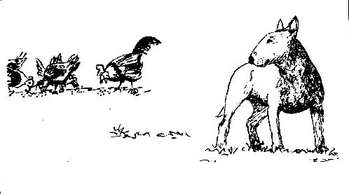
I unleashed Alice, and she ran hither and thither, the picture of a happy pup exploring ... until she changed breed. Just like that. One minute a Bull Terrier, the next, a pointer – no, I was wrong, a border collie – the type who fix a steely eye on their target as they crawl towards ewe (sorry!)
It seemed forever, but that is just the slow-motion effect which comes into play in moments of disaster – for such it was.
Alice sprinted, the chicken sprinted, Alice flew, the chicken flew. Fixed at a set distance apart of approximately two inches from last tail feather to point of canine nose, the pair circled the garden half a dozen times at the speed of sound.
Throughout, it remained fairly quiet – I think that the chicken was too breathless to squawk loudly, and Alice too serious to divide her energies. I seem to remember Mrs. PPP saying "It's all right" in the tone I would expect the captain of the Titanic to have used to his passengers – reassuring, but unbelievable.
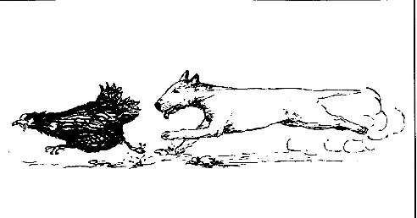
I think that there was a background murmur, possibly me repeating "ohmigawd" continuously; I know that on the sixth circuit the chicken realized that the patio doors were in fact open, and shot into the house, across the living room and under the sofa. So did Alice.
All motion ceased for a millisecond as we all said "Ohmigawd" very loudly, and then followed, piling onto Alice and hen in order of nearness – Mrs. PPP, me, then David.
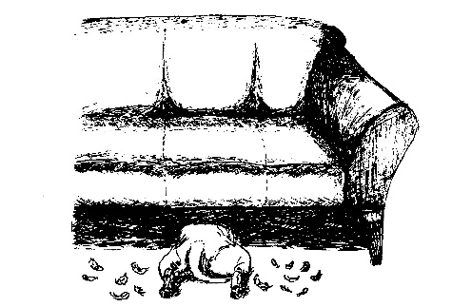
Standing in silence, ankle deep in feathers, I thought the worst. I had never visualized how chicken chasseur might occur, but possibly this had been it.
Like passing a ball through a ruck, Alice was passed back, with a feathery grin... which on closer inspection turned out to be a mouth so fat with feathers that it was unable to close. Hanging on tightly to the canine delinquent with one arm, and surreptitiously attempting to remove as many feathers from her jaws as possible with the other hand, I watched Mrs. PPP, holding a bald bird, exit with great rapidity.
David, meanwhile, appeared to have disappeared. He hove into view shortly before our hostess' return and I forbore to ask him where he had been.
For the remainder of our visit we were treated as welcome guests, (even Alice), and The Incident as one more part of life's rich tapestry. Lucky Alice to have found such besotted and heroic owners.
On the return journey, I admit I succumbed to hysterics, somewhere north of Newbury on the A34. This was facilitated by the discovery of David's whereabouts when he vanished. He had dropped to floor level behind the sofa in an attempt to pick up as many feathers as possible while our hostess dealt with the hen. Three quarters of the bird's 'foliage' now filled David's pockets.
Days later we were still finding the odd feather, and it took a fortnight before I had the courage to ring and ask after the hen's welfare. Though bald, the now pink hen had never even stopped laying, and Mrs. PPP seemed surprised that I felt the experience merited such concern. Truly, some matches – of dogs and owners – are made in Heaven.
© A. Abrahams
ILLUSTRATIONS BY VICTORIA PATAKY

