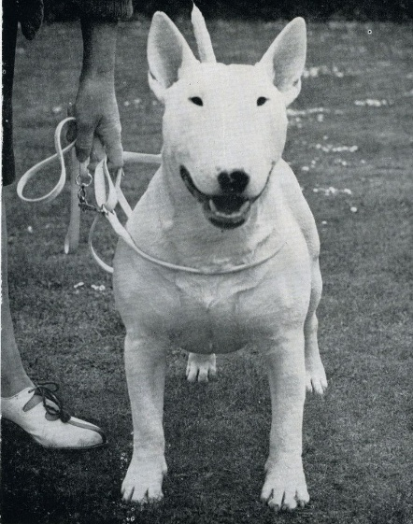
BULL TERRIER TYPE IN ENGLAND
By Raymond Oppenheimer (Reprint from Bull Terriers of Today, 1951)

The kennel name of “Ormandy” stands at the very top of Bull Terrierdom in England, and Mr. Oppenheimer has a world- wide reputation for his understanding of the breed. He has often judged Championship shows and has been unusually successful in breeding to type. His remarks on Bull Terrier type in England are authoritative and, since we in the United States tend to follow the lead set by England, should receive careful study.

My friend, Mr. Earnest Eberhard, has asked me to write something on Bull Terrier type in England and I am here trying to carry out his request.
First then, type anywhere is and must be the prime essential of every breed since, in the final analysis, it is only type which differentiates one breed from another or the pure bred from the mongrel. Now to pass from the general to the particular, correct Bull Terrier type as we see it in England is a blend between the terrier and the bulldog on to which is added the various specific points as set out in our Standard.
A departure from that correct type towards an undue emphasis of the terrier or bulldog characteristics we regard as very bad, as also any houndy tendency because we feel that the dog immediately ceases to conform to the basic demands of the Standard which was grounded upon the conceptions of the men who evolved the original White Bull Terrier.
I have spoken of a blend and in that connection I should make it clear that in our view the blending not only applies to individual tendencies but most important of all to the proportions. These agreed proportions are not simply the outcome of the whim of some bewhiskered ancestor of the modern fancier, they are on the contrary based upon sound mechanical knowledge as to what best constitutes theoretically the ideal fighting machine. With that in mind the framers of our Standard demanded width of chest for stability, shortness of back to give maneuverability and quick turning power, and enough length of foreleg for reach and agility. On to these proportions they added the other necessary points, e.g., correct shoulders, strong hindquarters and so on to complete the perfect fighter.
So far so good, but there were in addition some points added on for purely aesthetic reasons, such as a white coat, no wall eyes and other points which we all know, until there emerged the picture of a splendid animal complete in every detail and of a type quite unmistakable.
Having said so much, I am going on to make use of something I have written elsewhere because I think it will fit into the pattern of what I have tried to say here and complete the fabric: when it was previously published it was called “A Pen Picture of a Bull Terrier” and I make no apology for repeating it with certain emendations since it sets out, as well as I can do it, what I think a Bull Terrier should look like.
Beginning then with the head, looked at full face it should appear long and strong and it should be oval or egg-shaped, that is to say it should be filled up everywhere so that the surface has upon it no hollows or bumps, and there should be a minimum of loose skin, especially round the throat and mouth, while the forehead should be flat from ear to ear and not domed or peaked like a gnome. The cheeks should be flat and clean and not coarse and lumpy, while the ears should be on top of the dog’s head and fairly close together and should be capable of being held by the dog stiffly erect, when they should point upwards and neither sideways nor forwards. When all these features are present, the head gives a general impression of smoothness almost as if it had been “blown up” with an air pump.
In profile the head should form nearly an unbroken line curving slowly downwards from the top almost to the end of the nose where it should for the last half inch or so curve down a little more steeply producing that feature generally referred to as the ‘Roman finish”. Continuing in profile, the head should give an appearance of depth and should look neither shallow nor bird-like, nor should the profile be so exaggeratedly curved nor angulated as to cause the dog to look like some kind of sheep, and lastly the head should be in proportion to the rest of the dog.
To finish with the head, there is one other feature of paramount importance and that is the dog’s eye and more particularly expression. The eye itself should be as near black as possible and it should be well sunk into the head; the opening into which the eye is sunk should be high up the dog’s head so that the distance from the nose to the eye is perceptibly greater than that from the eye to the top of the head. Further, the opening should be small and it should be triangular and above all slanting so that it points upwards and outwards-with these features the dog will have the true Bull Terrier expression which, for me, contains something of the gay, proud, mischievous and brave and much of the impassive, repelling and inscrutable.
Now let us pass to the rest of the dog; he should have a wide chest with straight front legs and clean shoulders, i.e., ones that are not rounded or bulgy when looked at head-on, they should be firmly attached to the dog’s body and the shoulder blades should be well laid-back; that is to say, that a line drawn from the front and bottom of the shoulder blade to the top and back of it should point up over the middle of the dog’s back and not directly upwards only just behind his head. When the shoulder blades are thus laid back, the dog’s neck comes into its body in a clean sweep and not at that very unattractive near right angle which spoils so many quite nicely arched necks. A neck that is reachy, arched and muscular and sweeps smoothly into the line of the back is one of the most distinguishing marks of a good Bull Terrier.
Looking down on the dog’s back, the spring or bowing of its ribs should be plain to see and he should be much wider across his back than across his loins. Looked at sideways, the dog’s brisket should be much nearer the ground than its belly and it is this formation which gives an appearance of lowness to ground as opposed to the ill-balanced bull-doggy stunted appearance of so many with too short legs.
Continuing to look at the dog sideways, its back should be short, strong and level until the loin where there should be a slight rise, or roach as the term is, after which the line should curve smoothly downwards and be set off nicely by a tail which should be attached to the dog low down; it should taper from base to tip and be carried parallel to the ground. Beneath this should come well-muscled broad hindquarters leading on downwards to a well-bent stifle and a well-angulated hock giving almost an impression as if the dog were slightly crouched to spring. Another important attribute of a well-made dog is that the various parts of the body should be in proportion to each other, that is to say, the length of the leg to the width of the dog, to its length of back and so on and it is of paramount importance that the dog should neither be nor look disconnected.
Finally, when the dog moves the front and hind legs should travel in parallel straight towards the observer and straight away and the dog should cover the ground easily and with a swinging springy stride, his front legs reaching out well forward and his hind legs flexing easily at the stifle and hock and moving smoothly, truly and strongly from the hip, the dog carrying himself proudly and in one piece.
I have so far only dealt in detail with head, with make and shape and with proportions, but if to that we add big round, but not coarse, bone, strong ‘cat’ feet, a temperament obedient but full of go and muscles rippling beneath a shining coat, we shall have gone a long way to describing a dog in which every feature is in proportion to all the others so that the predominating impression will be, not of some outstanding point but of a general level of all round excellence approaching the Standard’s description of a “strongly built, muscular, active, symmetrical animal, with a keen determined expression, full of fire but of sweet disposition, amenable to discipline”.
No one has ever bred the perfect Bull Terrier, no one ever will, but in the struggle to approach more and more nearly to the unattainable lies the source of so much happiness to so many and in the foregoing words I have tried to paint a picture of the particular unattainable, which we in England are trying to approach.

