Cecil Aldin
By Brian Kenway, (reprinted from the Spring 1989 Bull Terrier Club Bulletin)
Most Bull Terrier lovers will have heard of Cecil Aldin. His drawings of the Bull Terrier 'Crackers', often in company with other of his dogs are famed throughout the Bull Terrier World. Although his occupation was an artist it could have been stated as Dog Owner such was the number of dogs owned by him. He had a large number of pets, not only dogs but of several species, and of which, to we Bull Terrier people, Crackers is the most famous.
They were referred to by him as his partners, and his board of directors. So often did they 'sit' for him that they developed the patience of professional models. His work appeared in many forms and in many countries, and in addition to illustrating books he was also the author (he says Author-Artist) of several. I particularly liked the dedication in Dogs of Character (1927)...
To absent friends.
A silent toast to the row of little tombstones in my garden.
...in the rear of the same book appears a drawing of Crackers and Micky, the Irish Wolf Hound, with the acknowledgement...
The Author-Artist thanks his two friends for their invaluable assistance to him in the preparation of this book. CA.
It is interesting to note that included in the small list of Secretaries to breed clubs is The Bull Terrier Club, a club which for a number of years he was Vice President. In his book The Cecil Aldin Book (1932) there were a number of famous contributors including P.G. Wodehouse, the famous Cricketer Jack Hobbs and 'Beachcomber', who I remember as a major and regular columnist of The Daily Express until fairly recent times.
Over the years there were many on the 'board', Woggles the terrier who achieved immortality by appearing as a regular contribution to The Daily Sketch, a National Newspaper now defunct, although others were also famous in different capacities. With the present-day television, and it's instant entertainment and comedy, it is now difficult to realize how visual amusement was imparted. Commercial artists were a prime medium and their work was extremely popular. Magazines and Newspapers vied to promote the art of these household name artists, each with a vast following, and Aldin was in the vanguard of these, he certainly had the correct format and even his dogs were household names. With an Aldin cartoon there may or not be a caption, but there was no attempt to make the looker break into guffaws of laughter. One looked, appreciated and enjoyed, that was sufficient, all were captivated, dog lovers or otherwise.
We Bull Terrier folk look on Aldin as our property, and collectors eagerly obtain his books or pictures, but also in the other breeds he favored which include the mentioned Crackers, Micky and Woggles; the Scottie so often shown with Crackers, Furrier the Fox Hound, Fan the Hunt Terrier, Loopy the Dalmatian, Turps the Dachshund, Bogle the Rough Terrier, Blighter the Sealyham and Gyp the Fox Terrier. The list does indicate the wide range of breeds he owned.
I am never sure if he really desired any particular breed, or just gathered them whenever fate thrust an attractive puppy or dog under his nose. Certainly, it was the wise dog that sought to attract Cecil, for they all seemed to have enjoyed a happy and interesting life. I suspect that he was a 'dog lover', loving all but favoring no particular breeds. Certainly, his knowledge of dogs was greater than he ever admitted, his writings indicating this although he always relates the stories simply with himself playing a minor role. He brushes away Micky's three first prizes in Irish Wolf Hound classes by saying the other contestants were not present, and although he confesses to winning two prizes at Salisbury in the late 1920s, he goes on to state they were Micky, the Irish Wolf Hound winning THE MOST POPULAR DOG IN THE SHOW and Crackers, the Bull Terrier, THE UGLYIST DOG IN THE SHOW!!! Personally, I think Cecil must have got this a little confused and reversed the awards.
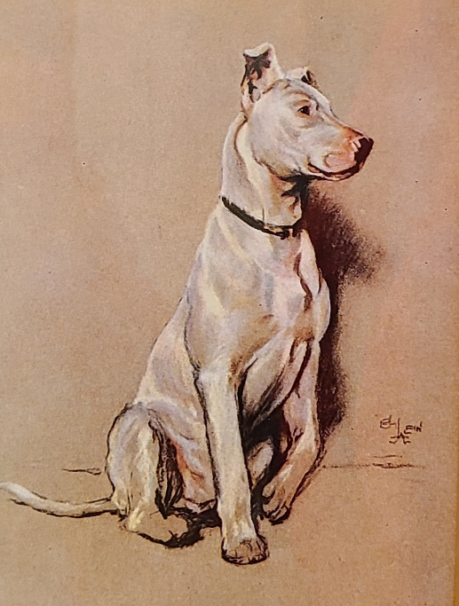
Micky and Crackers, constant companions, were both bought on the same day. Cecil and Mrs. Aldin were at tea with an Irish Wolf Hound breeder. Present was a 'good looking lady breeder of Bull Terriers' (Who was that??). Mrs. Aldin decided Cecil should buy her a present, a three-month old Irish Wolf Hound puppy, and by coincidence the BT breeder had some three-month old puppies also. 'No, I do not want a Bull Terrier!' said Cecil. Need we say more?
Cecil, an engaging character, has given successive generations of dog lovers great pleasure. Although his dogs have joined 'the row of little tombstones' they are vividly brought to life by his animated drawings, and will continue to bring pleasure for many generations to come.
To continue… A letter from Mrs. Margaret Sweeten (reprinted from the Winter 1989 Bull Terrier Club Bulletin).
In the last Bulletin, there were some interesting notes about the great animal portraitist — Cecil Aldin. A long time ago — sometime in the 1950s, I was walking through the village with my Bull Terrier, 'Conkie'. A smart car drew up and a woman ran across the road.
'Forgive me, I just must talk to your dog'
'Of course'
'How my father would have loved him; I must rush but I couldn't pass him!'
Off she went before I collected my wits and asked her name.
Some years later, we put our house on the market and within hours, the agent told us that the house was sold. We said that it couldn't be — no one had been to see it. The buyer wanted the house because of the dogs! 'We're not selling the dogs!' 'Oh! She knows that, she wants the house where they've been!'
The sale went through and who should she turn out to be but the enthusiast of long ago. She was CECIL ALDIN'S DAUGHTER!
I visited her and heard so much about his 'Cracker'. How he was at all times no. 1 dog and he and 'Mickey' were the only house dogs.
When he retired to Ibiza, his daughter had to escort a whole shipload of dogs out to him, and once there, they seem to have lived as a pack. She explained the context of some of the pictures. Cracker on the wall by the gate was how he supervised the entry of the 'gang' when the dog's dinner bell rang.
When we left the old house, she gave me the original pastel drawing of Cracker. 'Because my father would have liked you to have it'. I treasure it.

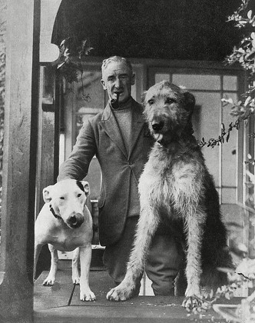
Why are these dogs so special? I could understand someone buying a house because an eminent person had lived there. But my delightfully wicked, adorable Conkie has left a trail of happiness to share with all our friends.

