Colour Breeding, Observations on Mrs. M.O. Sweeten’s Article in the 3rd Bull Terrier Book
By Margaret (Meg) Williams -- Reprinted from the Bull Terrier Club Bulletin Winter 1970.

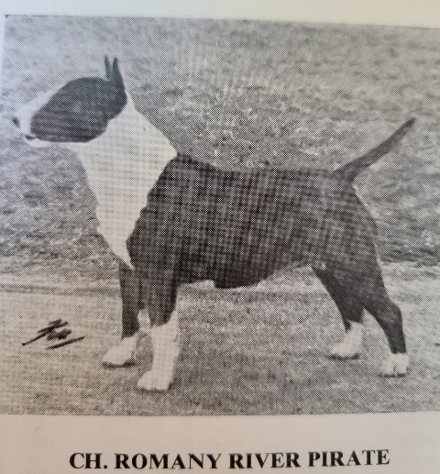
I read Mrs. Sweeten’s article in the Bull Terrier Book with great interest and after much thought, have written a few observations and opinions on color breeding in general and how the use of solid colors has influenced our strain taking it as far as Romany River Pirate. I have not included solid-colored dogs or bitches belonging to other breeders, so I hope, as so little seems to be known by novices about color breeding, that more will be written about other solid coloreds by their owners.

Nor have I mentioned Romany Rudopest’s influence outside these kennels.

I simply cannot agree with Mrs. Treen that the colored are fighting a losing battle with the whites, or with Mrs. Sweeten that there has been an appalling decline in the quality of the colored. The best of the colored always hold their own with the whites in the ring.

When the breeders of whites use brindle sires to some of their top-class bitches they are not using them to get colored puppies, so the brindle dogs must have something!!!

The face that depresses me is that there are so few serious breeders of colored, the majority of puppies being sold as companions only.

We have bred very few puppies in the last five years, and any promising puppies we may have had, we would rather see go into good homes when they are small, than run them on for would-be exhibitors.

Because there are far more white litters bred than mixed or colored litters, and in these the percentage of brindles is small, as is the chance of them being the best. There are bound to be more good whites simply on numbers bred.

Because so many of the whites now carry brindle, and are mated to brindles we are getting nearer to having brindles or whites who are pure for brindle. This should certainly help both white and colored.

Of course, the coloreds need the white sires. If colored were mated together over a period of time, I feel sure type, quality, and substance would be lost, how much and how quickly according to the sires available and how wisely they were used.

Here I must say a little about: “Suppose Robin Goodfellow had been a good rich solid brindle”.
Would Miss Weall have used him knowing she could only get colored puppies?

If she had, Romantic Vision would have been red and white instead of white carrying red. In which case mated to colored bitches would undoubtedly have sired good solid-colored bitches, who in turn mated to one of the top class whites carrying brindle would undoubtedly have produced some first class well marked brindles, or mated to white bitches carrying brindle could have sired more top class brindles. Certainly, there would have been more chance of getting a good brindle son from him. I always think white dogs who carry red are much more likely to sire good bitches than dogs.

Would Miss Weatherill have used Romantic Vision if he had been solid brindle, brindle and white, or red and white?

I do not care for pale colors ie fawn, pale red, silver or grey brindle or tricolor where the tan is pale, but I wouldn’t hesitate to use any of these if the animal was top class.

It seems comparatively easy to get the bright colors back, by using whites providing the color they carry is bright or by using rich brindles, or reds or blacks providing the brindle or tan on them is bright.

Two pale colors mated together will not be expected to produce bright colors, and two bright colors mated together will not be expected to produce pale ones.

I would always consider type, temperament and soundness before color, but a really well bred good looking solid brindle bitch can be worth her weight in gold to a breeder of coloreds. Mated to a white whatever color he carries you will always have 100% colored puppies, and a chance of some good brindles. Solid reds and fawns must not be overlooked. Whatever they are mated to they will also produce 100% colored puppies, but must be mated to whites carrying brindle or black brindle or brindle and white or black and white, if you are to get any well marked brindle puppies.

Solid black brindles and tricolors can be useful too. The tricolors must be mated to well-marked brindle and whites or whites carrying brindle, the black brindles must be mated to well-marked reds, fawns or brindles or whites carrying brindle, fawn or red. If mated to blacks or to whites carrying black or brindle, black and tan, I would expect the result to be 100% blacks. Although some people really love the blacks the best colors for selling are the well-marked brindles or reds, a small minority love the fawn smuts.

The solid colored dogs are nothing like so useful as the solid bitches. The breeders of white Bull Terriers will be reluctant to use them, and the breeders of colored will not have a large choice of good white bitches to mate them to. If mated to solid colors they will sire 100% solid colors, and to well-marked coloreds at least 70% solid colors and these are not at all easy to sell. Two well marked coloreds mated together usually produce 25% white, 25% solid colors and 50% well marked. This is only a rough estimate, and I would like to know the results other breeders expect.

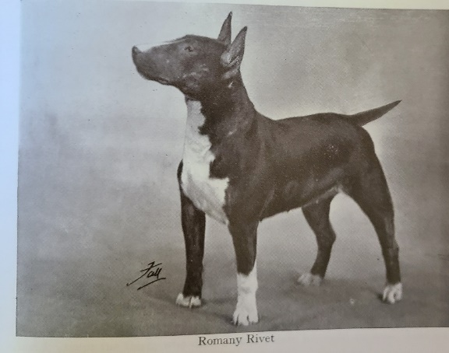
Solid colors and how we have used them:

Romany Rivet by Contango Cobblestone (solid brindle) and grandson of Ch. Romany Rhinestone (solid red) out of Northorpe Nonpareil. A mismarked red and white. Although Rivet had almost identical markings to Romany Rather Lovely and Romany Roast Goose who were barely 50% for color, she was solid and mated to Ormandy’s Sunny Day (pure white bred) produced Ch Romany Reliance.

Marle Hill Miniver Solid red smut by Still Water (solid brindle) ex tricolor Betty of Thistlewood (by solid brindle—by a solid brindle ex solid bright red). Miniver mated to Reliance produced a black and tan, a black brindle and white and two well marked brindles, Romany Rather Lovely and Ch Romany Rough Weather (River Witch’s great-grandfather).

Marle Hill Miniver. Mated to her grandson Ch Romany Rather Likely, a well-marked red brindle produces at least 75% solid coloreds including Romany Rest Cure (solid fawn smut). Romany Rest Cure mated to Ch Romany Rich Reward (well-marked silver brindle and white) produced at least 60% solid coloreds (one a top-class brindle bitch who went to America. We made a mistake here I am afraid). But there were two well marked brindles. Ch Romany Refreshed (silver) and Romany Restored (dark grey), 1CC and 13 res.
Refreshed mated to Ch Romany Rhinegold (red and white smut), produced Ch Romany Rhinewise (fawn and white smut), and Ch Romany Rhinemaiden (red brindle and white).
Refreshed. Mated to Ch The Sphinx, produced Romany Golden Boy (clear fawn and white). Golden Boy mated to Ch Romany Robinsonya (brindle and white) sired Ch Romany Robin Goodfellow.
Romany Golden Boy mated to Ch Romany Rhinemaiden sired Ch Romany Rock ‘n Roll (bright red and white). Rock ‘n Roll mated to Goodfellow, produced Romany Ruderpest (solid red brindle).
Romany Ruderpest mated to Ch Romany Romantic Vision the first-time produced Ch Romany Romantic Rite (well-marked bright brindle) and the third time Romany Romantic Nomad (well-marked bright brindle).
Romany Romantic Nomad mated to Ch Souperlative Sea Captain, produced Romany Roving Sailor (well-marked red brindle) and Romany Rover Scout (well-marked dark brindle).
Romany Rover Sailor mated to Ch Romany River Witch sired Ch Romany River Pirate (well-marked rich brindle and white).

In nearly 30 years we have used five solid coloreds to produce Ch Romany River Pirate.

One solid rich brindle dog (Cobblestone), one solid black brindle bitch (Rivet), one solid red smut bitch (Miniver), one fawn smut bitch (Rest Cure), and one rich brindle bitch (Ruderpest).

Next time you gaze at the rows of beautiful White Animals spare a thought for the brindles. They all played their part and the whites would not have reached their present standard without them.

