PUPPY LOVE
by Carrie Curzon (Reprinted from the BTC Bulletin 1988).
This is the story of canine courage.
It happened when a romp in the bush nearly ended in tragedy for mongrel Bobby Scruff, caught in a snare on his master's farm.
In the dense bush of the Eastern Transvaal, entangled in a mass of wires, he fought to get free – but the wires only cut tighter into his flesh. He would have died if it had not been for his loving companion, a brindle bull terrier, Bobbie.
She saw Bobby Scruff fighting for his life and came to the rescue.
For many hours loyal Bobby chewed her way through the snare, finally freeing her mate.
The dogs returned home late in the day, bleeding and exhausted – but alive.
The nine-year-old bull terrier is being treated as a heroine.
'It was quite amazing,' said the dog's owner, Dr Carlos Nobrega, on his return home from his Blyde River Farm. 'We were so worried about the dogs. They left early in the morning. 'They are usually back in an hour or so, but by the afternoon they still hadn't returned.'
Twelve hours after Bobbie and Bobby Scruff vanished, Dr Nobrega switched on his car alarm to summon the dogs, and planned a search party. 'There are a lot of snares on the farm and we feared this had been their fate,' he said.
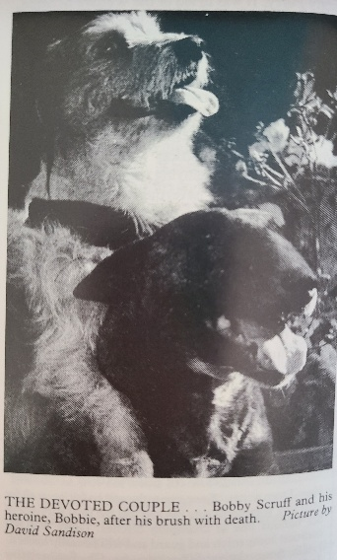
'Then we heard the bull terrier bark and the two appeared, Bobby Scruff still with the snare around his neck.'
The noose had been chewed off close to Bobby Scruff's neck and Bobbie's gums were bleeding badly.
'She was beside herself and came up to us whining and trying to tell us all about their ordeal. Then she slept, utterly exhausted, for 13 hours. I felt like weeping. I love that dog, she is almost human.'
*'Since Bobby Scruff was salvaged from the SPCA three years ago, the two animals have been inseparable.

