Patsy Ann
Bull Terrier Quarterly Centerfold
Summer 1992 by David Harris

October 12, 1929-March 30, 1942.
Sire: Gay Diablo-Dam: Patty Ann

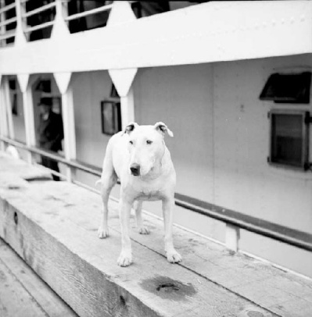
Traditionally, the Centerfold has been reserved for Bull Terriers whose fame stems from their prowess in the show ring and as illustrious sires or dams. Patsy Ann disdained such a regular approach to stardom. Instead, Patsy Ann gained renown as “The Official Boat Greeter of Juneau, Alaska.”
Her story begins in Portland, Oregon, where in October,1929 a litter was born of pedigreed Bull Terrier parents. The puppies were, of course, all white as that was long before the acceptance of the Colored Variety in America. A bitch pup from this was purchased by Dr. Keyser, a dentist in Juneau and so Patsy Ann was soon on her way to Alaska.
Dr. Keyser had hoped Patsy Ann would become a wonderful playmate for his twin daughters, Esther and Elizabeth. Alas, this was not to be.
Unknown to the family, Patsy Ann was stone deaf. She would not settle down with the Keysers, and so they gave her to Dean Rice of the Holy Trinity Episcopal Church, a neighbor who lived across the street and had two sons.
Unfortunately, Patsy Ann did not adjust to life with the Rice family either. Defying all efforts to keep her at home, she would slip her leash and head for the school grounds while the children were at play. Indeed, Patsy Ann loved to be around crowds, the more people the merrier. The waterfront was also a particular attraction to Patsy Ann, and soon she took to meeting the steamships as they docked, a task that was to become her passion in life and her claim to fame thereafter.
Patsy Ann left home and took up residence near the docks. It is said that she was never without a meal and a place to sleep. She frequented the old City Café, the Imperial Saloon, and in winter enjoyed toasting her toes in front of the pot-bellied stove at the old Alaskan Empire. But her favorite residence was with the longshoremen at their hall in Willoughby Avenue.
She anticipated the arrival of ships long before their whistles could be heard. It can only be speculated that she could sense the vibration of their engines as they approached. Also, she had an uncanny knack of knowing where they would dock. On one occasion Patsy Ann was waiting with the crowd for a Government ship to arrive at a particular dock, when she quietly trotted off to another dock, and, of course, this was where the ship actually arrived.
Whatever the hour, day or night, Patsy Ann would be there to greet each ship. Her friendly, dignified manner- so typical of the breed – warmed the heart of visitors and locals alike. It also assured her of treats appropriate to the status she assumed as Boat Greeter.
When off duty, Patsy Ann could be seen wherever there was a crowd. The story is told of how she halted a tied baseball game by taking the ball away from the pitcher. Eventually she tired of playing and retired to the stands for a nap, permitting the game to resume.
Then there was the time the City of Juneau moved against unlicensed dogs. Contributions from concerned citizens proved sufficient to provide Patsy Ann with not only a license but also a new collar, with which she was presented in recognition of her office as Boat Greeter.
The stories of Patsy Ann are legion. It was said she was the most famous canine west of the Mississippi and more photographed than Rin Tin Tin. The newspapers of the day provide records of her exploits, and she was the subject of a booklet published in 1939 by Carl Burrows.
In her younger days she would not allow any other dogs on the dock whilst a ship was in. But age brought a degree of tolerance, provided the other canines respected her special position.
Patsy Ann died peacefully in her sleep on the evening of Monday, March 30, 1942. On the morrow, at 12:30, her coffin was lowered into the waters of the Gastineau Channel over which she had watched for so many years. A large crowd of friends was present, a fitting tribute to Patsy Ann.
Now fifty years on, through the efforts of The Gastineau Humane Society and the Friends of Patsy Ann, The Alaskan Legislature passed a citation in her honor:
“The Seventeenth Alaska State Legislature takes great enjoyment in recognizing the contribution of Patsy Ann, ‘Official Boat Greeter of Juneau, Alaska.’ She did not seek fame, only to bestow friendly greetings to all she encountered – a job she undertook with dignity, persistence and single-minded dedication. Fame found her on its own.
“Born totally deaf, she nevertheless anticipated not only the arrival of all incoming steamships, but also at which of Juneau’s docks they would be tying up. Cynics surmised she was attracted by the occasional morsels of food tossed through the portholes by kindhearted travelers; but the truth was, she loved people. The bigger the crowd, the better. Baseball games were her favorites; her penchant for charging the field and absconding with the ball earned equal amounts of player’s ire and spectators’ delight.
“Patsy Ann was as much a fixture of beer parlors and hotel lobbies as any paying guest. She was pointed out by cab drivers and photographed by tourists. Her image adorned postcards sold by curio shops. She even appeared in a talent minstrel show for which she endured the humiliation of a bath.
“Here distinctive gait slowed over the years due to rheumatism brought on by unscheduled dives into the cold waters of the Gastineau Channel. Still, she always headed for the docks on the double whenever steamship whistles shook Juneau’s boardwalks. Human Alaskans will forever hold Patsy Ann’s name dear – longer, certainly, than those of many so-called bipeds amongst them.”
…Surely Patsy Ann should take her place in BTQ’s Centerfold, alongside the Bull Terriers that have gained fame and fortune by more conventional means.
(Notes by DH, Acknowledgements: The Juneau Empire, Carl Burrows and the Trevor Davis Collection-Alaska State Library.)
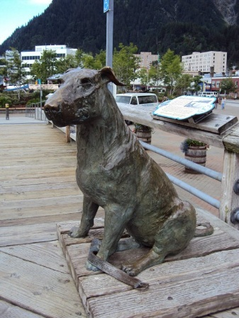
Addendum - The Friends of Patsy Ann unveiled a permanent bronze greater-than-lifesize sculpture of Patsy Ann at the Marine Park, close to her old haunts, on July 3, 1992. Sculpted by Bull Terrier’s own Anna Burke Harris, Brummagem BT’s. Clippings from dog hair all over the world were included in the bronze at the time of casting, symbolically uniting the spirit of dogs everywhere. Every visitor is encouraged to “greet her and touch her and in leaving, carry with you the blessings of friendship through your life’s journey.” May her spirit live forever.

