DO BULL TERRIERS CHEW?
By Peggy Arnaud

Now I would not wish this to be read by anyone but Bull Terrier owners, because Bull Terrier owners are by nature forgiving or we would not be Bull Terrier owners. But yes, they chew alright, and anything. What is more, they not only chew, they swallow. There I was bathing Duffy. I placed the sponge on the side of the tub, picked up the towel, and the sponge was gone. It just disappeared like ectoplasm. We couldn’t get it up and he couldn’t get it down, so off we went to surgery. In due time the sponge was returned to us intact and ready again for use and now worth $65. So it now has a string laced through it and is tied to the tap, and the dogs have to amuse themselves by eating the soap or drinking the bathwater.
Trouble only chews eyeglass cases. If you happen to unknowingly drop the case on the floor and the glasses are still in it, he will remove them carefully and then reduce the case to a sodden, revolting, and unrecognizable mass.
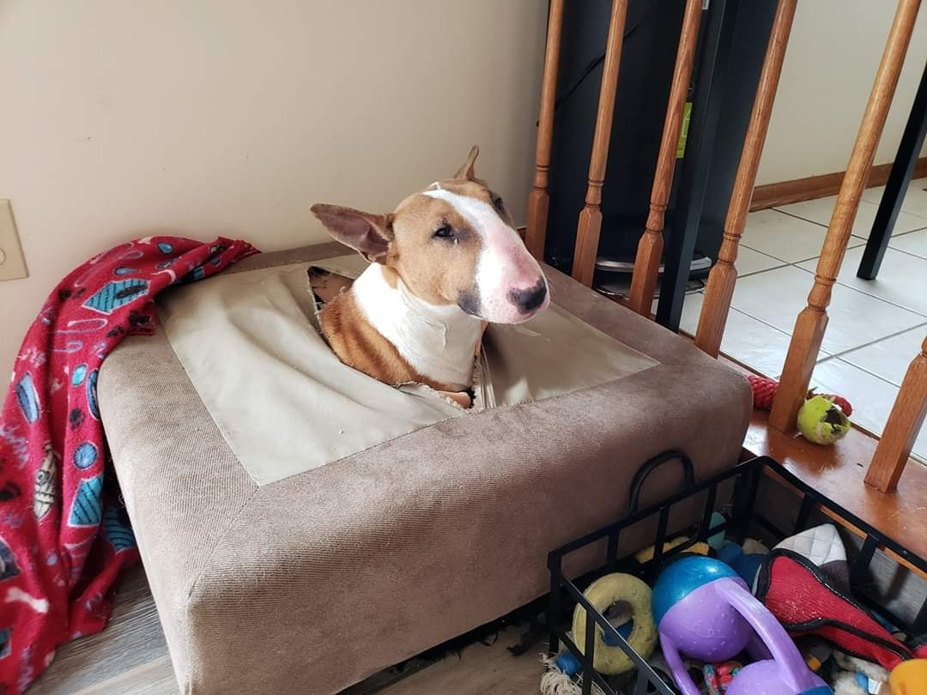
One afternoon when we were out, Knockout, who was only a puppy, chewed his way out of his box, took the telephone receiver over onto the rug and spent a lovely afternoon gnawing away on it. We were then on a very busy party line and I am sure a few people were wondering to this day about those very strange sounds, to say nothing of the heavy breathing. Luv had, I say “had” advisedly, a swinging door leading to her outside run and one day she ate the end part that contained the magnets. My veterinarian, who is now hardened to this sort of thing, made some remarks about stomachs like vats of acid and suggested that I watch to make sure she passed it. Eventually she did and there, clinging to the magnet was a Phillips screw, a bottle cap, and a small unknown object, probably the vital missing part the loss of which causes the vacuum cleaner to roll the dog hairs up in little balls instead of depositing them evenly over the rug as was its previous habit. I am not suggesting we feed magnets to clear the stomach of foreign objects as said artifacts could have been in place on the magnet before it was devoured - but maybe once a year along with their rabies shot!
But our Muffin, Ragged Hill’s Check Eater, is the best of the awful lot. One summer afternoon she was sitting in the middle of the living room pondering on the

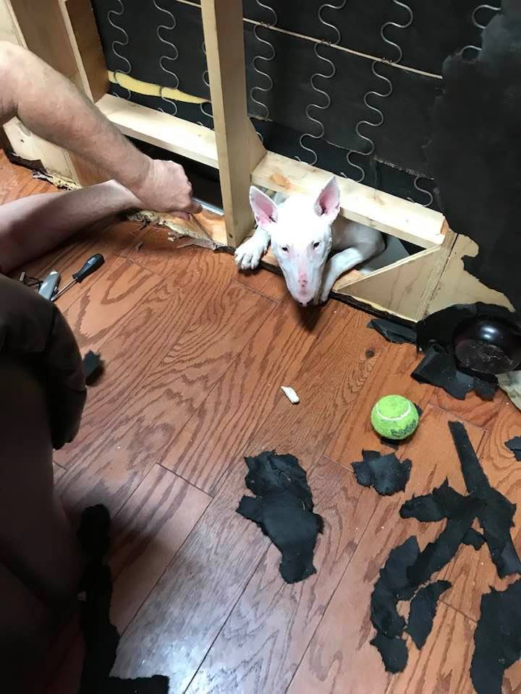
possibility of redesigning the Colonial table legs - a little Hepplewhite maybe - or even Oriental - when a stray breeze from the window blew a check off the desk. She didn’t even move her position, just opened her mouth and $100 was deposited in Muffin’s stomach. She ate a sock that had blown off the laundry line and was delighted with peroxide and water that was syringed into her in an attempt to recover my husband’s hand knitted argyle that he was probably pleased to see the last of, licked up what had spilled on the floor and went happily to sleep frothing gently at the mouth. At that age she was always carsick, so down to the end of the road and back and that problem was solved.
Another example, her ears were a little soft so we taped them with quantities of surgical tape and gauze wrapped hair curlers in the ears. In the night she removed the whole arrangement and ate the lot. Off we went for a ride in the car and up came everything. Believe me this is not a fun thing to do before breakfast.
And so it goes. Things are constantly missing, perhaps it is due to my random housekeeping but perhaps my veterinarian was right about the vats of acid. I am positive that saucepan lid was in the kitchen at lunchtime yesterday. Now it is late and only two sounds break the silence of the winter night - the big trucks changing gears over on Rte. 9 and Muffin, who foiled by aluminum strips around the edges of her box, is working on an emergency exit in the rear and destruction will be completed in the morning.

Reprinted from the 1973 Colket Memorial Book of Bull Terriers.

