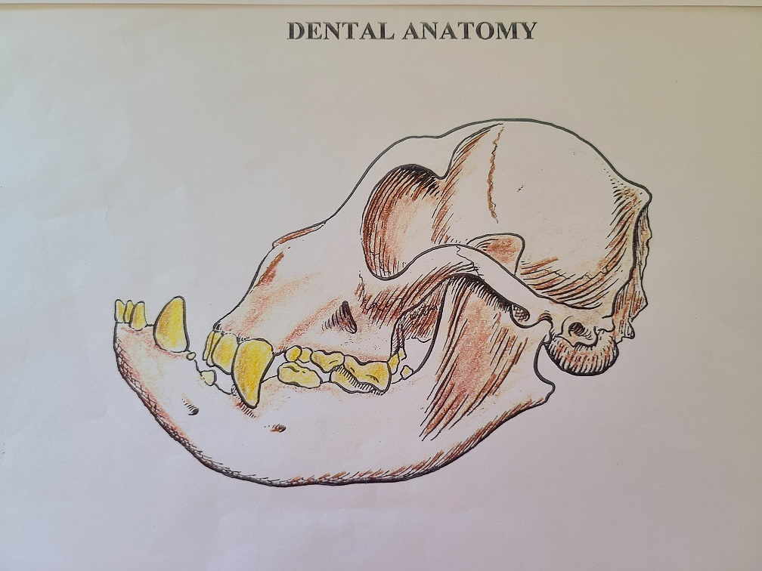

Breeder’s Education Silverwood 2018 – Dr. Peter Emily, DDS, Hon. AVDC presents Dental Anatomy, Base Narrow Canines

Here is the video presentation done by Dr. Emily for the Silverwood Breeder’s Education seminar in 2018, along with a booklet on canine anatomy that Dr. Emily had authored and bestowed to us. It is very informative. And yes, this IS a Bull Terrier skull. We hope you both enjoy this presentation and learn from it. It was such an incredible honor that Dr. Emily took his time to participate in this venture. Offering us his unbelievable store of knowledge, and in such an engaging manner. Please take time to read his full biography, he is an amazing man and innovator, who has done so much and shares what he knows. We also want to acknowledge and Thank Dana Bowers and Melanie Whitehair for their generous help with the preparation and execution of this Zoom presentation. It could not have happened without them.

Some general questions we asked Dr. Emily to address in his presentation:

Our membership is not unique, in general, dog breeders just lack a basic knowledge of dental issues, especially jaw growth and tooth exfoliation. Added to this is our breeds’ unique melding of the bull and terrier heads, and propensity to exaggerate the desired egg shape. Given this, many breeders’ have expressed concern over what possible detrimental effects could occur with the ever more dramatic curve to the profiles in Bull Terriers.
- Does the increasingly curved profile shorten the head length (foreface) thereby leading to crowding teeth?

- Several breeders expressed concern over what seems to them to be a greater frequency of missing teeth (premolars and molars). Should this be a concern?

- The questions of in-standing canines (base narrow), and their seeming entrenchment in many lines.
  - How does it occur and is it genetic or developmental in nature or both?
  - How serious/ detrimental a problem is it?
  - Any suggestions on how to breed away from the problem? Increased length and width of fore face?

- Breeders noted that several general vets suggest removal of all deciduous teeth to aid in the eruption of permanent teeth – believing that the permanent canines have a better possibility of correct placement. Is this helpful or harmful? Or how about the use of “ball” therapy (chewing on a rubber ball)?

Biography – Dr. Emily is an accomplished human and veterinary dentist with a career spanning over 50 years. He received his Doctor of Dental Surgery at Creighton University, Omaha, Nebraska and his Certificate of Periodontology from the University of Pennsylvania. Dr. Emily later went on to receive his post-graduate certification in Pediatric Dentistry, Endodontics, Oral Surgery and Restorative/Prosthetic Dentistry from the Dental Division of Denver General Hospital.
Dr. Emily is any Honorary Diplomate of the American Veterinary Dental College and the Academy of Veterinary Dentistry. He currently holds the position of Faculty Affiliate of Animal Dentistry at Colorado State University, School of Veterinary Medicine, is a past Dental Faculty Affiliate at the University of Missouri at Columbia, and performs Exotic Animal Dentistry for the Denver Zoological Gardens. Dr. Emily is a past president of the American Veterinary Dental Society (AVDS). When the AVDS wanted to become a board specialty, Dr. Emily was one of the four veterinarians who approached the specialty board to understand the requirements for board recognition. Dr. Emily was one of three veterinarians who developed and administered the initial Academy of Veterinary Dentistry entrance exams.

Later, the three veterinarians and Dr. Emily developed and administered a 3-part exam process for acceptance into the College of Veterinary Dentistry, and this same 3-part format is still used today. Additionally, Dr. Emily designed the logo and the pins for the AVDS, and AVD and AVDC, as well as those for the review and assessment exam, and also hand casts a custom gold medallion for the Research and Education award for the AVDS.

When Dr. Emily graduated from dental school in 1959, the standard operating procedure for animal dentistry was limited to cleaning and extractions. Dr. Emily became involved with judging show dogs, and in the capacity as judge, was regularly coming across dogs born with problems as defective bites and missing teeth. An innovator and inventor, Dr. Emily adapted tools used in his human dental practice to be usable in the reparation of animal dental problems.

For years he has helped the animals of Siegfried and Roy. The Denver Zoo also calls upon Dr. Emily to perform repairs on the beak on hornbills and toucans, as well as caring for kangaroos, wild dogs, polar bears, grizzlies and orangutans, to name but a few of the many species on which Dr. Emily works. In the early days, many zoos did not have the proper facilities for working on exotic animals, so improvisation was key. For example, at the Denver Zoo, Dr. Emily improvised, using the hydraulic lift of a pickup truck to perform a surgical root canal on a polar bear.

Dr. Emily has also worked on animals in the wild, such as a black-footed ferret, for which Dr. Emily fashioned a gold tooth. Through Dr. Emily’s efforts, in the 1980’s, Colorado State University was the first school to offer a course in Veterinary Dentistry to students and practitioners, presented and taught by Dr. Emily. Dr. Emily has written and presented extensively including author and co-authorship of three veterinary dental textbooks and multiple dental publications and manuscripts.

He has lectured extensively on all phases of animal dentistry for over 20 years to veterinary groups and dog clubs throughout the USA, Europe, Australia, New Zealand, China, Brazil and Japan. In addition, he has conducted extensive research and development of veterinary dental medicaments and oral health aids.

Dr. Emily is also a retired AKC Working Group judge. Dr. Emily began judging Doberman Pinschers – his foundation breed- in the late 1970’s, and has judged at the US National Specialty four times. Dr. Emily has also lectured all over the United States on the biomechanics of movement in dogs.

Although semi-retired, Dr. Emily continues to work with the Denver Zoo, Siegfried and Roy, local veterinary hospitals and shelters, and with local rescue groups, as well as on any interesting case that is put in front of this ever-curious innovator and lover of animals. When not working in the mouths of people and animals, Dr. Emily serves as the Dental Consultant and Conformation Judge for the American Kennel Club. However, Dr. Emily devotes the majority of his time to working with the foundation he started – The Peter Emily International Veterinary Dental Foundation – providing veterinary dental services and education to exotic animals around the world residing in sanctuaries, shelters and zoos.

