TRADITION BOUND
David C. Merriam remembers a lifetime spent in the sport of Dogs

By Denise Flaim

Today’s dog world is arguably an anachronism, with even the term “the sport of dogs” giving off the violet-posy whiffs of a Bronte novel.

Amid a backdrop of TikTok videos and AI-scripted college papers, our dog world is a step back to much simpler times — exemplified by exhibitors who reflexively dispense “sirs” and “ma’ams,” a dress code more at home in a “Mad Men” episode,
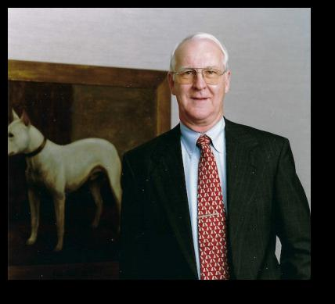
and prescribed conduct where dialogue heard with regularity on HBO is grounds for a tribunal.

Most of those trappings of centuries past are, of course, veneer: Over the last few decades in particular, the sport has had to make huge concessions to modernity, from the furious hopscotching forced upon Westminster as the city to which it is tethered metamorphosizes yet again, to the webinars that instruct new judges and the Zoom sessions that have supplanted parent-club annual meetings.

But not everyone has accepted the inevitability of an American Kennel Club no longer moored to its Victorian roots. And if there is anyone to whom we could turn to adjudicate the current state of the sport, it is the Hon. David C. Merriam, as he was known on the bench in his home state of California, where he served for two decades as a trial-court judge. From his early days as a Bull Terrier devotee to a judging career that included star turns at Montgomery and Westminster, to his tenure at the helm of the American Kennel Club’s board


of directors, the now retired Merriam has seen a deep cross-section of the sport — always with a self-deprecating, self-effacing spirit that itself harkens back to a much different time.

Merriam, shown in his home library, was chairman of the American Kennel Club from 1996 to 2002.

Fittingly, earlier this month Merriam became the most recent inductee into the Anne Rogers Clark Hall of Fame, an honor that was announced at the Purina® Pro Plan® Show Dogs of the Year Awards on Sunday night before the Garden.

Merriam began in the sport obedience-training a tricolor Collie under the tutelage of Bill Koehler— unsuccessfully, he is quick to admit. But the precise moment he considers his start in dogs was at the Orange Empire show in 1952, when a 14-year-old Merriam tried his hand at junior showmanship.

“At that time, the Dark Ages, junior handling was very new — you just showed up to the ring with your dog,” he recalls. “I went into the ring with 60-pound Bull Terrier who dragged me around it, and I left with a fourth-place

rosette. I suspect there were only four people in the class.”

That, effectively, was Merriam’s beginning and end in junior handling. In later years, “I judged it a couple of times,” he says.

“At that time there wasn’t any standard for it. Then of course there were the parents outside the ring. It was always a lose-lose proposition.”

Merriam’s enthusiasm for the Bull Terrier, however, proceeded unabated. He won a California specialty show the following year with his first Bull Terrier, a white bitch named “Gigi” who was a gift from the retired colonel who gave Merriam lifts to dog shows.
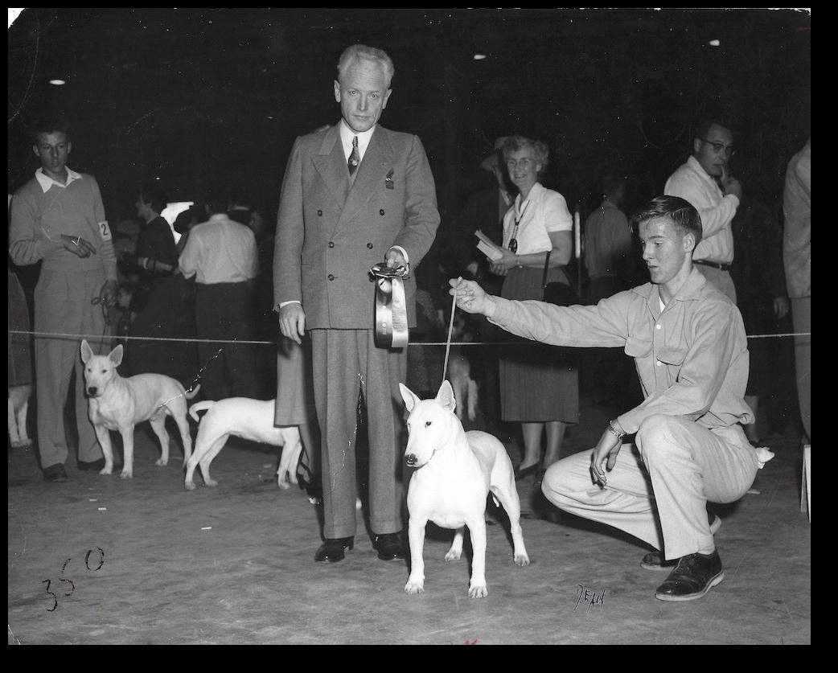

Merriam showing Ch. Mars Gigi, Best of Variety under Billy Kendrick at the Los Angeles Kennel Club show in 1953.

“With that, I was hooked,” Merriam says of Gigi’s long-ago triumph at only one year old. “I found that winning was more fun than losing in obedience.”

Merriam showed his last Bull Terrier in 2019, and in the intervening seven decades, he logged in multiple Best in

Show and national-specialty honors, serving as president of the Golden State Bull Terrier Club while in law school. In later years, Merriam was president of the Bull Terrier Club of America and the Riverside Kennel Club, where he was also showchair.

“I think everybody gets sort of chauvinistic about their own breed,” he says with characteristic tact about his devotion to his chosen breed. “Bull Terriers are a fun breed. They’re not as crazy as some of the Terriers, and they can be a little
headstrong. They’re a fairly easy dog to live with, and amusing.”
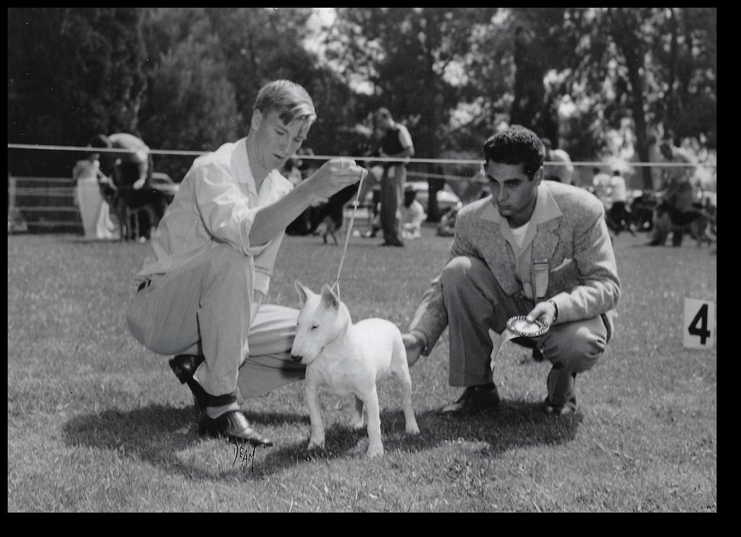

Merriam at age 16 shown winning the 1954 OEDC Puppy Match in Ontario, California, with a puppy bitch sired by Ch. Nightriders Rasteau. Judge Ric Chashoudian, himself in his early 20s.

Bull Terrier people can be just as single-minded as the dogs they love, so much so that they have become something of a breed apart within the AKC system. Fanciers tend to eschew all-breed shows in favor of specialties,
or Register of Merit (ROM) shows, which can only be adjudicated by a small clutch of approved judges.
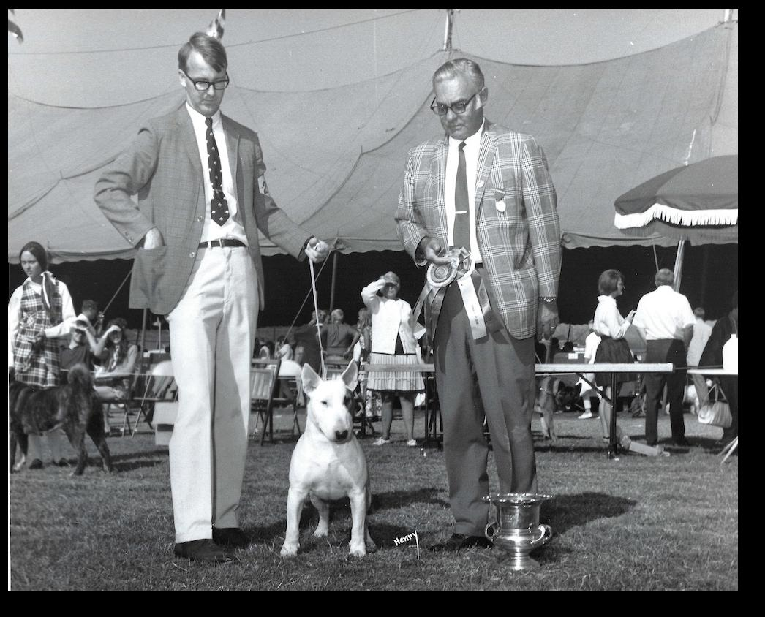

Best of Variety at Santa Barbara Kennel Club, date unknown, with Ch. Sadlewise Sandpiper. Photo: Schley.
“That’s developed only in the last 20 to 25 years, before which the breed got battered around by all-breed judges who knew nothing about it,” Merriam explains of the Bull Terrier’s relative insularity. “So the fanciers sort of turned inward. It’s very much a within-the-breed breed.”

Another reason for the breed’s provincialism, he posits, were its earliest years. “Originally, they never had within the breed a handful of wealthy people who could promote the dogs, who could get the group and Best in Show placements.”

The exception that proved the rule, however, was Raymond Oppenheimer, the British breeder and author who has become synonymous with the Bull Terrier. The general dog community knows him for his pithy, matter-of-fact list of “20 Breeding Principles” that make the rounds of Facebook periodically. (Number three is always a favorite: “Don’t take advice from people who have always been unsuccessful breeders. If their opinions were worth having they would have proved it by their success.”)

“Raymond was a tremendous influence on the breed and on myself,” says Merriam, who would visit Oppenheimer for several weeks just about every year once he graduated law school. Oppenheimer was, famously, an heir to the DeBeers diamond-mining fortune. “After the Second World War, he could either go into the family diamond-trading company, or he could play golf, which was one of his passions, and raise Bull Terriers,” Merriam explains.

Obviously, Oppenheimer chose the latter.

“Raymond was a terrific breeder, and he bred some really great dogs for a good period of time, but he was never terribly good at conveying that,” Merriam reflects. “What I really learned from him was pedigrees. He had a phenomenal memory, and he would remember the merits and demerits of dogs two
and three lines down in the pedigree, which is really helpful when you’re breeding a breed that has several types.”
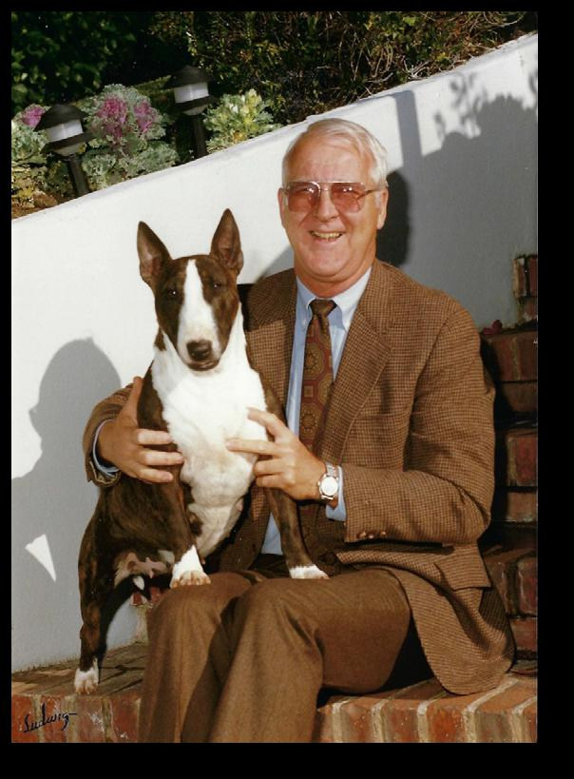
Merriam with a homebred Bull Terrier, undated. Photo: Ludwig.

In Bull Terriers, Merriam explains, those include Terrier type, Bulldog type and the upstanding Dalmatian type. “How you combine those influences, how you compile virtues and try to avoid faults
— that was Raymond’s ability.”

His love for Bull Terrier irrevocably set, Merriam was approved by the
American Kennel Club to judge Bull Terriers in 1967. Across the pond, he judged both the Regent Trophy and Crufts shows, and is an honorary member of the Royal Kennel Club, as the English entity is now known.

Eventually, Merriam was approved by the American Kennel Club to judge the entire Terrier Group. In the ultimate honor for a Terrier man, he judged Best in Show at all-Terrier Montgomery — not once, but twice — as well as the Terrier Group at Westminster in 1982.
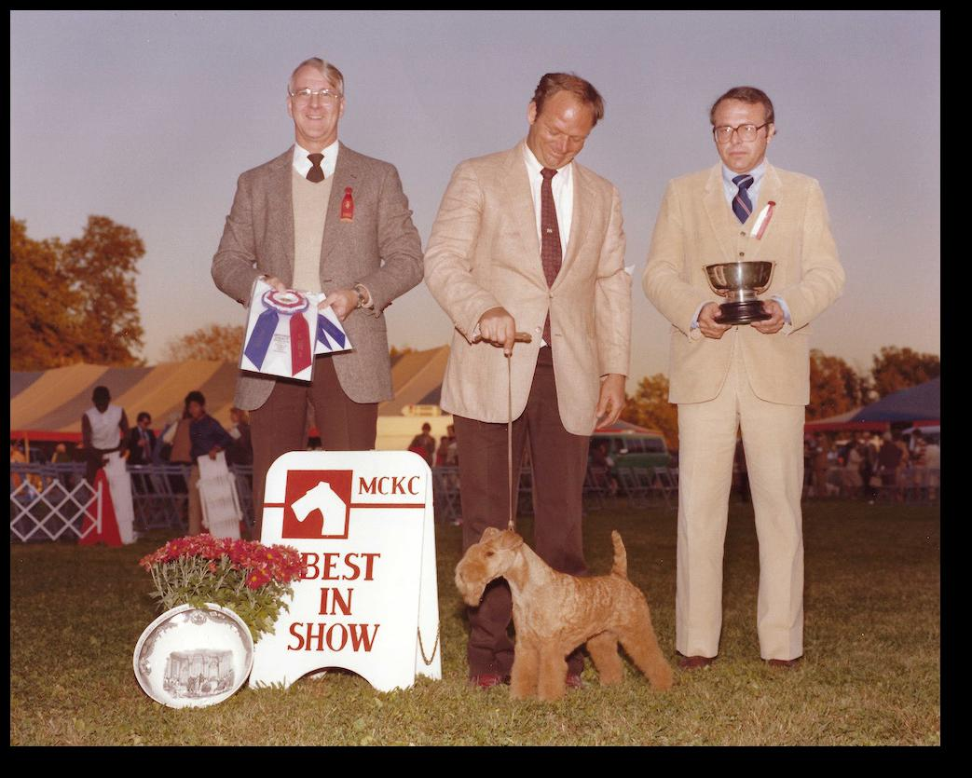
sort out a strong Winners Dog or Winners Bitch class,” Merriam remembers. “But judging Best in Show is much easier.”)

Nonetheless, when the call from then-Westminster show chairman Thomas Bradley III came, “I said, ‘Oh, Tom, I’m not qualified to do that,’” Merriam recalls. “I asked Tom if I could think about it. Which was audacious to the point of ridiculousness.”

Eventually, he admits, “my ego conquered my reason, and I called him back and said, ‘OK, I’ll do it.’”

In the end, on that famous green carpet in Madison Square Garden, a tuxedoed Merriam gave the nod to the 15-inch Beagle bitch Ch. Tashtins Lookin for Trouble, owned by Eddie Dziuk, and Lori and Kaitlyn Crandlemire, and handled by Will Alexander — only the second Beagle to win a Westminster Best in Show. As for Merriam, he thinks he is the only judge to just award one all-breed Best in Show in his entire career, that being Westminster.
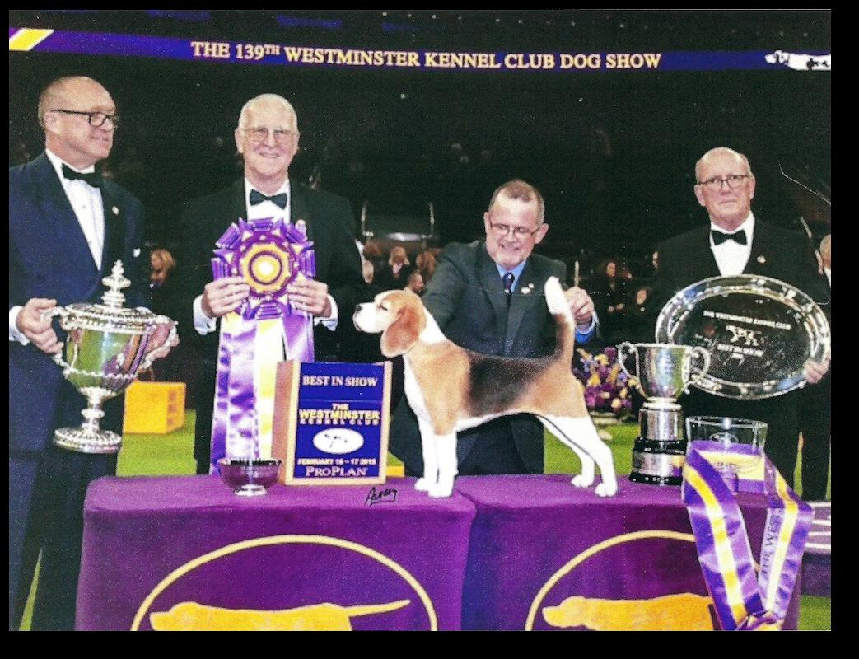

Merriam awarding Best in Show at the 1982 Montgomery County Kennel Club show to the class Lakeland bitch Ch. Jamboree’s Jubilea, handled by Eddie Boyes. Dr. Josephine Deubler and Walter Goodman presenting. Photo: Ashbey.

Then, in 2015, came the invitation to judge Best in Show at the Garden. It was, for Merriam, a “shock”
— but not for the reasons one might think.

“I never thought much at all of Best in Show judging,” says Merriam, who thinks no judge is so well versed on each of the 200 AKC-recognized breeders to be qualified to judge at that level. “Though I was approved to do Best in Show when I was approved to judge the Terrier Group, I never accepted an assignment. I would sort of decry it when other people did it.”

Indeed, years ago, in a column he wrote for this magazine, Merriam proposed that immediately after judging an all-breed Best in Show, judges should be whisked away by the AKC rep and be required to complete the breed-standard test for the breed they just awarded.

“If the judge fails it, then the award would be withdrawn. No one would object, as no good sportsman would want to be awarded Best in Show by an incompetent judge,” he concludes, tongue firmly ensconced in cheek. “But like many of my suggestions, it was not well received.”

(It should be noted that Merriam’s beloved mentor had a different perspective on the final competition of the day, famously suggesting that judges first be approved to judge Best in Show, because the seven group winners were arguably all sufficient in quality as to make a bad decision rather unlikely. By contrast, the depth of understanding required of breed judging was an altogether more difficult proposition: “Raymond said it takes a fair amount of ability and training to successfully

Merriam officiating at Westminster in 2015.

Outside of the ring, Merriam was chairman of the board of the American Kennel club from 1996 to 2002. He was the earliest proponent — along with Irish Setter man Ted Eldridge — of group shows, knowing of their tremendous success in England for more than a century. Like most new
things, the idea encountered resistance, but was eventually approved two years after Merriam left the board. “They’ve become popular and a good addition to AKC,” he says.

Perhaps less beloved among exhibitors were the first AKC disciplinary guidelines, which Merriam authored.

“AKC is a regulatory agency, and part of that is discipline. Part of the discipline standards go to the history and tradition
of the sport,” he explains. “It’s like in tennis: Do you really want to tolerate the players throwing their rackets down and crashing them down over other people’s heads? And likewise in our sport, I don’t think it’s being an old duffer to say there has to be civility among serious competitors.”

In that same vein, Merriam was also the author of the “AKC Code of Sportsmanship,” which grew out of a committee

charged with developing rules to address conflicts of interest.

“It turned out that’s impossible to do,” Merriam shrugs. “You can either make it in very general terms, and then no one knows what you’re dealing with, or you can make it in very specific terms, and then you can’t possibly account for every situation. I concluded and the committee concluded that the best way is to state some goals and hope that carries the day.”

Looking back, Merriam doesn’t know if it’s done anything to encourage good sportsmanship.

“You can encourage it as a tradition, and that’s what we tried to do,” he says. “The preface to the code is in that tenor. I think that’s the reason the sport has lasted so long. It does have some basic elements of civility and sportsmanship.
If it didn’t, it would have broken down long ago.”

What has changed is an increased commercialization in the sport — both inside and out.

“The American Kennel Club is a strange anomaly — it’s both a dog club and a commercial corporation. Their goals aren’t always the same,” he reflects.

Add to that the unprecedented burst of growth in the AKC after World War II, when prosperity fueled increases in everything from home ownership to procreation. (Hello, Baby Boomers.) Purebred-dog ownership became another badge of prosperity. “It was an artificial increase,” he says of registrations, one that began to taper off in the 1990s. “People had some money, they were
spending, and an AKC dog was a sort of prestigious thing to have.”

Assuming that registrations would just continue their upward trajectory, AKC counted on this revenue to underwrite its less profitable endeavors, including dog shows. “It’s not

very difficult to build up a bureaucracy when you’ve got lots of money,” Merriam notes. “The difficulty is in reducing bureaucracy when you don’t have lots of money. That’s when AKC started to turn to how do we really commercialize our sport, so we can afford to keep the structure.”

One of these efforts to widen the tent — and by extension the revenue stream — was permitting mixed breeds to participate in performance events such as obedience and agility. Merriam was a vocal and unapologetic opponent of taking this tack, even going so far as to toy with the idea of having a corporate subsidiary to handle all the “fun” activities, leaving AKC for just conformation and field-trial people. “I just learned the other day we now have flyball competitions, and trick competition,” Merriam says. “My God, have we really gone off …

“When I think of the American Kennel Club, I think of the three pillars: breeding, exhibiting and judging,” he continues. “If you knock out the pillar of breeding, you’ve really warped the purpose of AKC.”

That same shift in focus has permeated the conformation aspect of the sport as well, with young people more interested in the flash of showing rather than the satisfaction of breeding, and the win record of a single dog
eclipsing the lifetime accomplishments of a kennel.

“The sport has gotten far more commercial than it did before, although in a strange way,” Merriam says. “There have always been people with a lot of money in the sport, but if you go back to the 1910s, ’20s and ’30s, they had kennels and hired staff — they put money into producing dogs, showing and competing.”
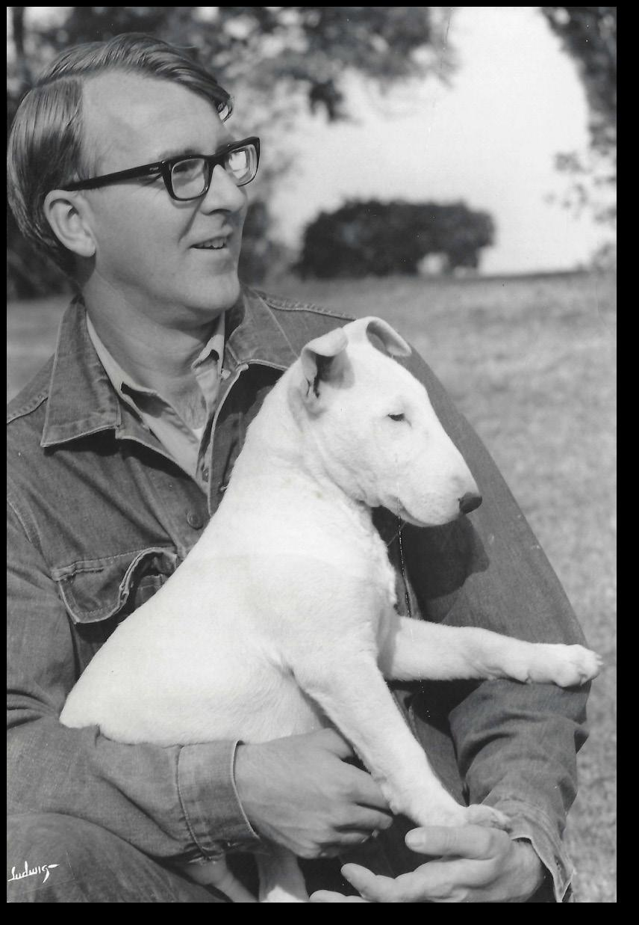

With a Bully friend, early 1960s.

Today, by contrast, while there is still big money in the sport, the emphasis is on lining up and signing on to the best dog a handler can find, as opposed to breeding it themselves. “I find that’s less satisfying than putting money into breeding dogs.”

Then again, perhaps the more things change, the more they stay the same. When Merriam joined the AKC board as a 40-something, all the other members were at least 20 years his senior, and “there was no desire to change anything.” The unwieldy size of the groups — which underlies the current call in some quarters for group realignment — was just as hot-button an issue during the formation of the Herding Group
in the 1980s, a process he remembers as a “bloodbath.” As for judges, the AKC has always spent “an inordinate amount of money” approving and evaluating them, “and it really doesn’t prove to be very efficient,” whether it’s the one-man rule of Len

Brumby or the trickle-down economics of Steve Gladstone. But then, beyond the politics, there are the people.
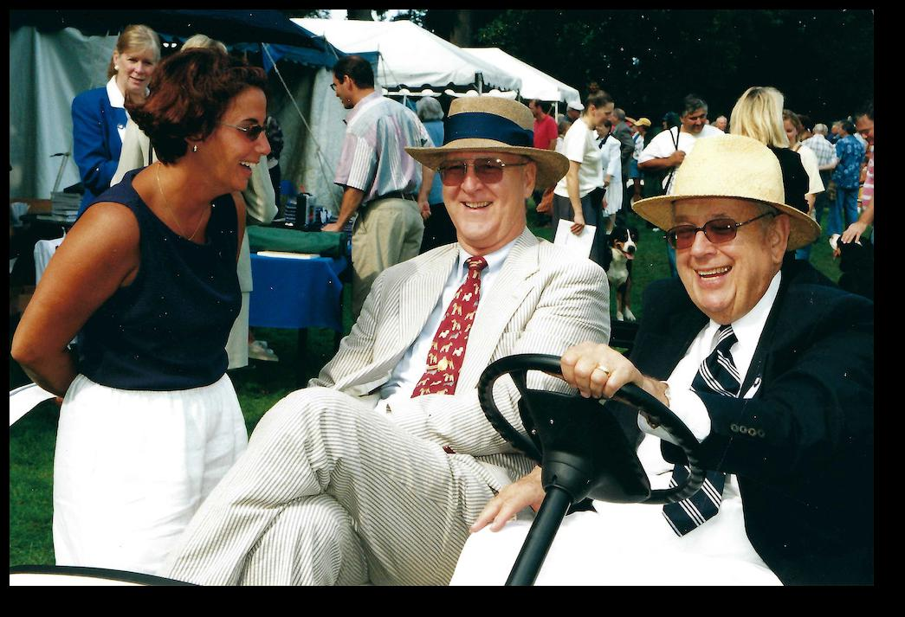

With Sam Draper at the Westchester Kennel Club, 2000. Photo: Mary Bloom.

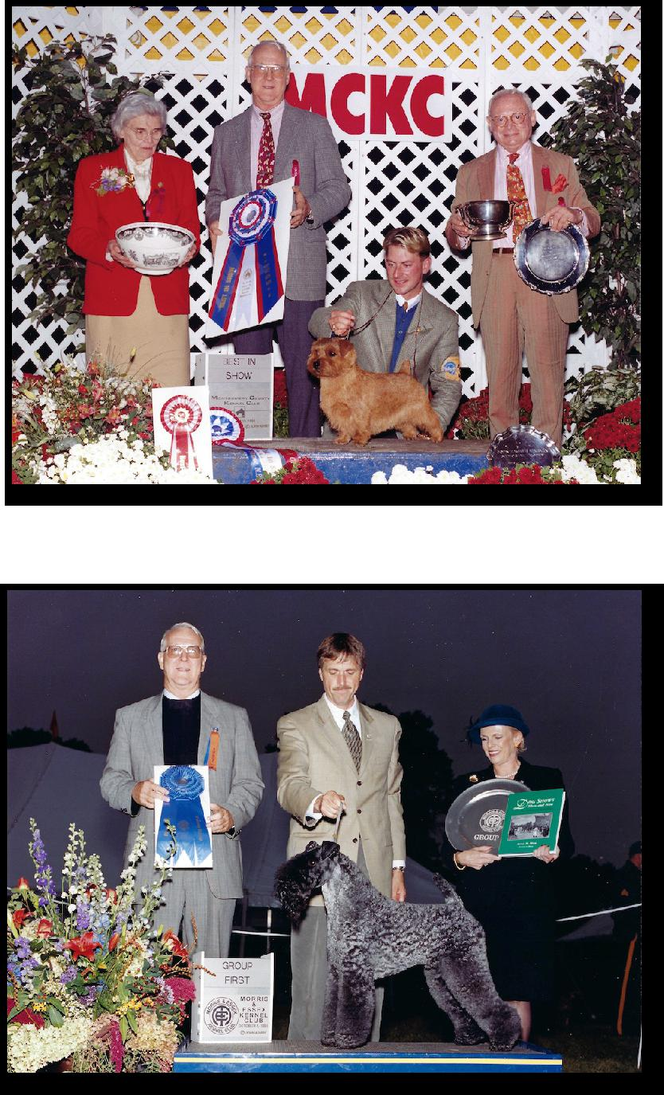

Merriam awarding Best in Show at the 1999 Montgomery County Kennel Club show to the Norwich Terrier Ch. The Duke of Copperplate, handled by Larry Cornelius.

“It’s an avocation that I enjoyed enormously,” Merriam says of his time in dogs. “Within the sport you have great variety of people involved, some with an enormous amount of wealth and social prominence, and others who are scraping their dollars together to get to the show. Somehow this great expanse of variety is good.”

As for the sport itself, reports of its demise may be greatly exaggerated. “Maybe there hasn’t been as much damage as I thought there would be,” Merriam muses. “I think it’s got such tremendously deep roots I’m not sure we can wreck it, even if we try.”

© Dog News, www.dognews.com. This article is reprinted here with the express written permission of

the publisher and author

Merriam awarding the group at the first revived Morris & Essex show in 2000 to the Kerry Blue Terrier Mick. Photo: Ashbey.
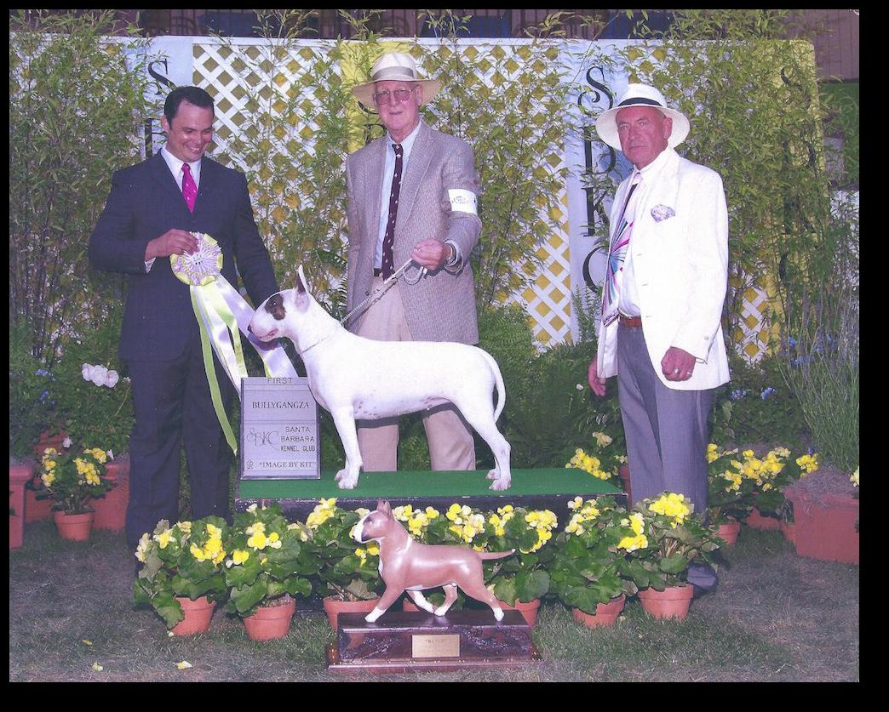

Merriam winning Bullyganza at the Santa Barbara Kennel Club with the White Bull Terrier Bestuvall Take It Easy, co-owned with her breeder Jan Dykema. At right, Desi Murphy

