The History of the Silverwood Trophy
Reprinted from “A Celebration of Silverwood Winners”, with kind permission of the authors Norma Smith and Naomi Waynee. (This material is copyrighted.)

THE SILVERWOOD TROPHY
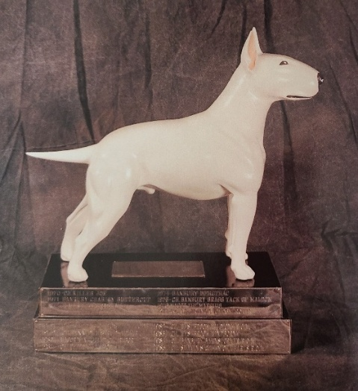

Given in memory of Bill and Hope Colket
For the best Dog or Bitch of the Year bred on the North American Continent.
Original Silverwood Trophy donated by the Bull Terrier Club (UK)

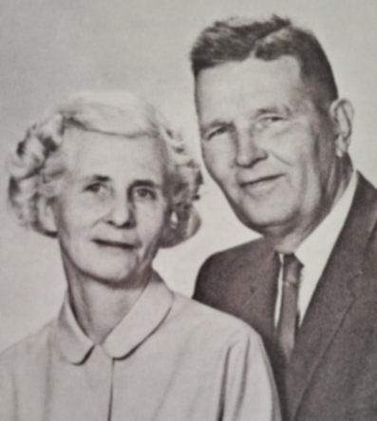
Hope and Bill Colket – Silverwood Bull Terriers
Hope and Bill Colket gave liberally of themselves for over two decades in the cause of the Bull Terrier. To both, what mattered most was not “your Bull Terrier or my Bull Terrier, but the Bull Terrier.”
Without the helping hands of Hope and Bill many novice exhibitors would not have continued to become knowledgeable breeders and exhibitors.
Hope and Bill stood for all that was best in our breed and our sport.
“Ave atque vale.” (Hail and Farewell)
William Kendrick

In the late 1960s, there had been a good deal of informal discussion between the leaders of the breed in North America and England regarding the institution of a Trophy Show in this country modeled on the annual competition for the Regent Trophy and Ormandy Jugs, which had been a singular focus for British breeders and fanciers since 1939, the first year that the Regent Trophy was a staged event. The tragic death of Bill Colket, an enthusiastic and capable American breeder who with his wife, Hope, had traveled extensively in Britain and imported English Bull Terriers to their Philadelphia based Silverwood Kennels, provided a flash point for the organization of the North American Trophy Show. When Bill died, Hope Colket and Raymond Oppenheimer began serious trans-Atlantic discussions about a trophy Show to be held in North America in memory of Bill. Such talks naturally involved the national Bull Terrier clubs in both countries and were in a very forwardly state when lightning struck again in the same place, and Hope Bishop Colket was killed in September of 1969.
PURPOSE OF THE SILVERWOOD COMPETITION
The purpose of this competition is to bring together at one time in one place America's outstanding Bull Terriers so that their virtues may be assessed and appropriately recognized. In this situation, breeders will have an opportunity to inspect America's top Bull Terriers and become acquainted with and talk to breeders from other sections of the country. They will be able to relate their own progress to the breed as a whole and make decisions concerning future matings that should move the breed forward at an accelerated pace. It is hoped that through this activity better understanding and closer cooperation will develop throughout the entire Bull Terrier fancy.
Trophy Table 1970.
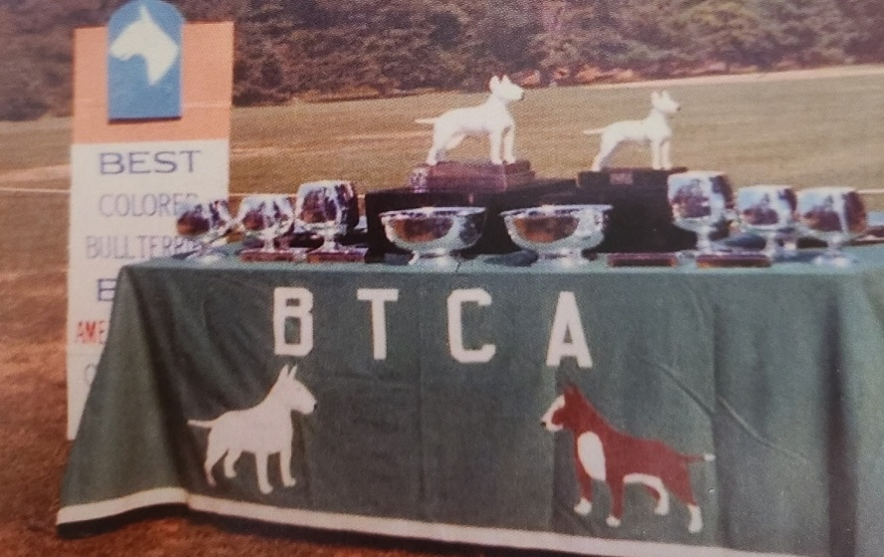

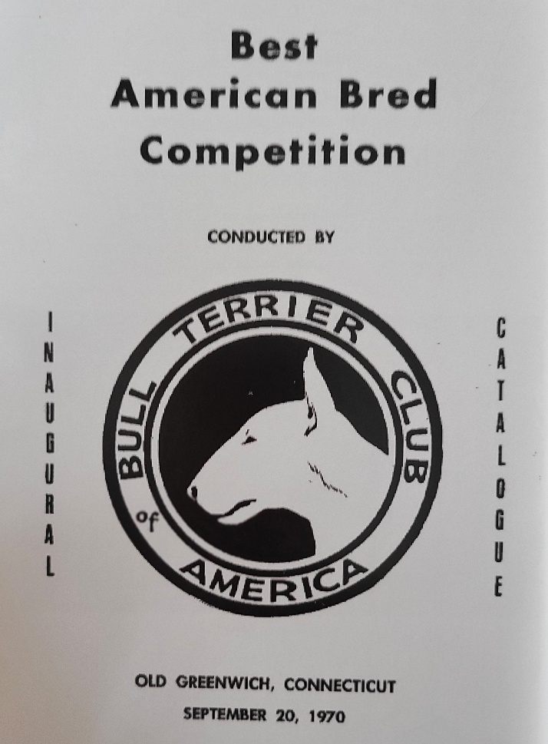

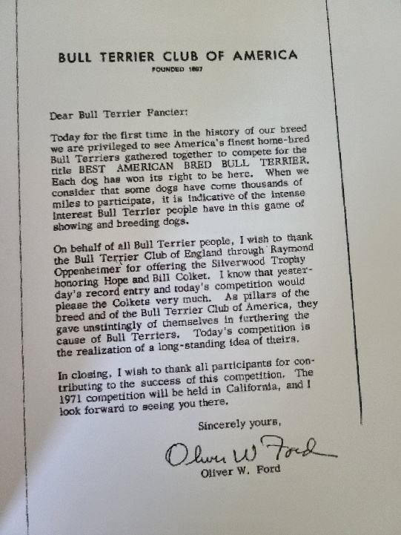

TROPHIES
THE BULL TERRIER CLUB
of England
offers in memory of Hope and Bill Colket the SILVERWOOD TROPHY for BEST AMERICAN BRED BULL TERRIER. Mr. Raymond Oppenheimer will make the presentation.

BULL TERRIER CLUB OF AMERICA offers trophies for
Best of Opposite Sex to Best American Bred
Runner Up to Best American Bred

Best Colored Bull Terrier
Best of Opposite Sex to Best Colored

Best White Bull Terrier
Best of Opposite Sex to Best White

Best Colored Dog
Reserve Colored Dog

Best Colored Bitch
Reserve Colored Bitch

Best White Dog
Reserve White Dog

Best White Bitch
Reserve White Bitch

Each Qualifier will receive a Rosette in recognition and appreciation of its participation in this competition.

BEST AMERICAN BRED BULL TERRIER
Name: Ch. Killer Joe
Color: White Sex: Dog
Sire: Ch. Krackton Robin of Wentwood
Dam: Holcroft Kowhai Lottie
Owner: Mr & Mrs Michael Arnaud
Breeder: Owners

Best of Opposite Sex to Best American Bred
Name: Midnight Melody
Color: Brindle & White Sex: Bitch
Owner: Breeder Chas A Fleming

Runner Up to Best American Bred
Name: Midnight Melody
Color: Brindle & White Sex: Bitch
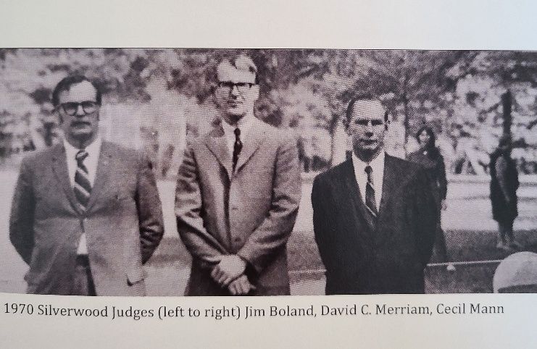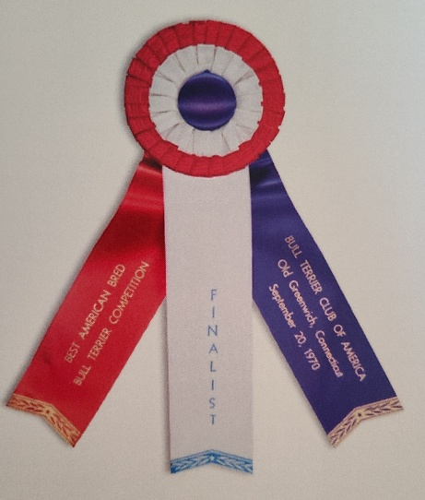

1970
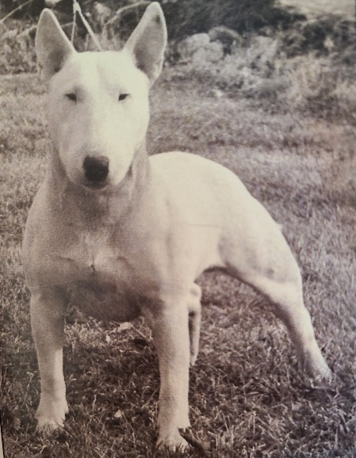
CH KILLER JOE ROM
Judges
James Boland, David Merriam, Cecil Mann
Owner(s)
Michael & Peggy Arnaud
Breeder(s)
Peggy Arnaud

Romany Golden Boy
Eng Ch. Romany Robin Goodfelllow
Eng. Ch. Romany Robinsonya
Sire: Ch. Krackton Robin of Wentwood
Ormandy Souperlative Snowflash
Eng Ch. Phidgity Flashlight of Wentwood
Phidgity Shepherdess

Abraxas Athos
Souperlative Acetylene
Souperlative Snow Mantle
Dam: Holcroft Kowhai Lottie
Eng Ch. Gazur Phidgity Constellation
Kowhai Fantasia
Kowhai Judy O'Grady

Old Greenwich, Connecticut - September 20, 1970 - 26 entries
A beautiful, sunny fall day on the grounds of the Greenwich Civic Center saw the first Silverwood Trophy Competition become a reality. Raymond Oppenheimer was on hand to present the Silverwood trophy donated by the Bull Terrier Club to the BTCA in memory of Hope and Bill Colket (Silverwood) to then President, Oliver Ford, and to the winning owner/breeder of Ch. Killer Joe ROM, Peggy Arnaud.
Killer Joe, dubbed "Trouble", triumphed as winner with relative ease. Observations quoted from Raymond Oppenheimer noted "the great Ch. Killer Joe; he exceeded my expectations and is a great dog in any language. He has a most beautifully filled head, a short back, a good front, nice hindquarters and moves well both ways. It has been said that to offer no criticism is to damn with faint praise and so I should perhaps say that more animation, a little more shape and more bend of stifle would turn greatness in perfection, but when all had been said against him, I cannot conceive of any year here when he would not have been a very serious challenger for the Regent Trophy and/or the Ormandy Jug".
When all the winners had been chosen and trophies awarded, Raymond declared it a "thrilling day and one which I would like to believe has lit a fire which will never be put out"! How pleased he would be to know that the fire indeed continues to burn brightly.

BEST AMERICAN BRED COMPETITION
Judge's critique - DAVID MERRIAM
Best Colored Dog - Highland's Big Ben
Brindle and White. Nice bone. Long well filled head. Good profile which could be improved with a bit more arch. Bite good. Rear movement exceptionally good. Front not especially pleasing nor front movement. A bit long in back. Ears carried well. Shown quite expertly. Won over Reserve on rear movement, neck and shoulders.
Reserve Best Colored Dog - Ali Baba of High Knolls
Brindle and White. Well filled head with good profile. Very nice shape and placement of eyes. Moved well in front but rather poorly in rear. Nice topline and rather shapely body. Would prefer a better lay back of shoulder.
Best Colored Bitch - Midnight Melody
Dark brindle and white. A truly sensational profile. Lovely shape to an elegantly long head. Body matches the head style. Superb topline and neck. Front is good. Has too much tuck up and could use more body. Movement is only average. Was not overly keen on showing but when left to stand on her own she took a classic stand. Good bite.
Reserve Best Colored Bitch – Ace's Dynamite Galore
Brindle and White. A superb showman. Very clean lines and presented in top condition. Head is strong and balanced but lacks finish. Eye could be smaller. Front is good. Movement fair. Topline not pleasing.
Best White Dog – Ch. Killer Joe
A very well-made dog with exceptionally good head Filled right up with very good profile. Eye placement and shape good but color too light. Bite not quite right. Nice topline and full body. Could be a bit more shapely. Moves quite well and has a good natural stance. Showed only adequately until allowed a brief flirtation when he pulled himself up to his full self.
Reserve Best White Dog – Tantrum's Trad Lad
Very impressive 8 months pup. Has a truly sensational head, fully filled, great profile and wonderful piercing dark eye. Has abundant bone. Has yet to body up and tighten up in rear and in front. Right now, moved rather sloppy rear and front. Has good topline and very nice coat.
Best White Bitch - Ch. Belle Terre's Patience (my Choice)
Shapely little bitch. Head, although short, is well filled and has a very pleasing profile. Nice lines in topline and underline. Short back. Bite not quite right. Good eye and expression. Movement only average.
Reserve Best White Bitch – Bridgit of Nottingham (My choice)
An elegant bitch with very nice reach and pleasing lines. Lacks required fill and profile in head. Showed exceptionally well. Even bite.
Best American Bred Bull Terrier - Ch. Killer Joe
The white dog over powered the colored bitch with better movement and body. Heads were close with his clearly masculine and hers elegantly feminine. Showed more confidently.
Best American Bred Bull Terrier, Opposite Sex – Midnight Melody"

CH. KILLER JOE ROM – "Trouble" –
Sire of:
- Ch. Belle Terre's Patience ROM - Best White Bitch 1970
- Ch. Ragged Hill's Lady Killer II – Reserve White Dog 1978
Sire of:
    - Westbrook Windsong
Dam of:
- Ch. Westbrook Windborne ROM – Silverwood Winner 1983, Best Colored And Best of Opposite Variety 1982, Best Colored 1981.
    - Westbrook Wild One –Silverwood Winner 1982
    - Westbrook Wild Thing – littermate to Wild One - White Dog Finalist 1981
Sire of:
- Ch. Westbrook Windborne ROM- Silverwood Winner 1983, Best Colored And Best of Opposite Variety 1982, Best Colored 1981.

      - Ch. Westbrook Whiz-Bang ROM – Reserve White Bitch 1982
Dam of:
- Thricer Abracadabra- White Bitch Finalist 1986
      - Ch. Hunstman's No Jemima ROM – Lovell Trophy Winner & Best White 1983
      - Ch. Terron’s Carolina Dinah ROM- White Bitch Finalist 1987

- Ragged Hill’s Like Luv
Dam of:
- Ch. Ragged Hill’s Aurora
Dam of:
- Ragged Hill’s Backstroker ROM- Best Colored Dog and Raydium Brigadier trophy winner 1980
- Ch. Ragged Hill’s Worthy Sam
Sire of:
- Ch. Ragged Hill’s Witchcraft – Reserve White Bitch 1977

