Movement: What it’s all about and why it’s important. by Tom Horner (reprinted from The Bull Terrier Breeder December 15, 1977).
For as long as I can remember, which is quite a long time now, the worst and most persistent fault in the Bull Terrier has been its movement. Let me say that though we still have many poor movers in the breed, movement overall is vastly better than it was when I started closely to observe the breed in the early thirties. What is more it has been shown in recent times that Bull Terriers can be bred to move quite as well i.e. as freely, soundly and accurately, as any other breed.
In those days, at least in England, the downface and how to breed it was the first consideration with almost everyone in the breed, this wonderful new head which had appeared like a genie out of thin air was what every breeder was trying to produce almost entirely regardless of the rest of the dog. Only a very small handful of people in the breed were overheard to talk about anything but heads and an even smaller number were in the least concerned with movement.
It is only fair to say that even though this concentration on points brought the conformation and movement of the breed to an appallingly low level at the time, if it had not taken place, it is most unlikely that we should have had the wonderful heads we see in the breed today. There were some very clever breeders at the time, the majority quite single-minded about breeding bigger and better downfaces.
It took a very long time to persuade people in the breed, with a few notable exceptions, that no dog can move correctly unless it is properly built and that the movement of the dog inevitably betrays the faults in its conformation, with the result that no matter how good its head a Bull Terrier that is wrongly made and/or moves badly is far removed from perfection. Unfortunately, this basic truth has not penetrated throughout the breed, there are still a great many breeders and judges at home and particularly abroad who pay little attention to movement or bother to learn to differentiate between good and bad conformation in the breed, and until this is generally accepted as necessary basic knowledge we shall continue to have a high percentage of breeders whose litters are full of little disappointments and judges who put up unsound dogs over better made ones, and the breed will go on faring badly when it comes up against other breeds in Terrier Groups and so on.
The Bull Terrier is a fighting breed and his conformation is such as to enable him to fight with maximum efficiency. To be an efficient fighter he needs a number of qualities developed to a high degree. He must have bone, a strong framework throughout; substance, plenty of width and depth with well-developed muscles, and strong ligaments knitting his joints together; agility, he needs to be fast on his feet, fully mobile and active; strength, particularly in the jaws, neck, loins, shoulders and hind-quarters with sound legs and feet to carry him into battle; determination, of that we are all agreed that he has plenty! And most important, balance, so that none of the qualities named above becomes a disadvantage by outweighing the others. A Bull Terrier too heavily built will lack agility and speed, one that veers too close to the Terrier will be deficient in power and weight.
In considering his movement, it is essential to remember what a Bull Terrier is designed for. He is not made to go to ground like a Fox Terrier, to course game like a whippet or to trot for hours on end in arduous conditions like a Husky. He is built to be the most effective of all canines in his sphere, that of the fighting dog. Like Muhammed Ali he should pack the hardest punch with maximum speed and efficiency, and with no waste material of faulty machinery in his make-up.
As a fighting dog a Bull Terrier needs a broad, deep and capacious chest, firstly to allow plenty of room for the expansion of heart and lungs in this extremely arduous activity and also to allow him to take up a relatively wider stance with his forelegs than is seen in most breeds, so as to make him more difficult to be knocked over or pulled down by his adversary.
This does not mean that he should have a great broad chest like a Bulldog with elbows protruding from his sides, but a good width of chest in harmony with the general size and balance of the dog. This width is carried back through the dog's body to the hindquarters. The chest between the forelegs will be somewhat narrower than behind the shoulders where it will bow outwards, narrowing again slightly as it approaches the loins. The "spring of ribs" is a two-dimensional factor, the ribs being rounded from top to bottom and, rather less so from front to back to give the desired body shape. The hind quarters like the chest should be broad across the top-over the rump-and considerably wider in proportion than is usual in other breeds. This is the seal of the dog's power in fighting-and in movement-the immensely powerful muscles in his quarters are the strongest in the dog's body.
We move Bull Terriers when judging them because as it says in the Standard of the Fox Terrier, "Movement or action is the crucial test of conformation". A clever handler can hide many faults when the dog is standing still, on the move it is very much more difficult to do so. We move them at the trot because at that speed it is easier to see what the dog's legs are doing than at faster paces. If he is sound at the trot he will be sound at any other pace.
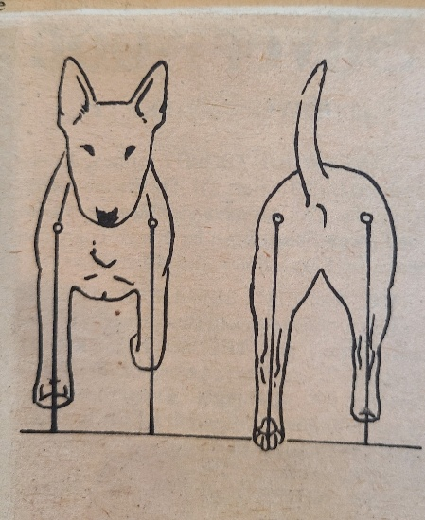
On movement the Bull Terrier Standard is very clear and explicit it says "The moving dog shall appear well-knit, smoothly covering the ground with free easy strides and with a typical jaunty air. Fore and hind legs should move parallel to each when viewed from in front or behind, the forelegs reaching out well and hind legs moving smoothly at the hip and flexing well at the stifle and hock with great thrust". This is very much easier to write down than to reproduce in the living animal, but it can be done. Ch. Souperlative Laura moved as well as any terrier I have ever seen, in a life-time of looking at terriers and she was only a superlative (no pun intended) example of what the breed can do when they come exactly right in conformation.
To achieve movement in the Bull Terrier as laid down in the Breed Standard the conformation of the whole dog must be pretty close to correct throughout. This breed carries in its background a strong dose of the Bulldog and as in any breed which has old Sour Mug behind it, there is a persistent tendency to exaggerations and unsoundness of the limbs and body structure, all of which lead to faulty movement in one way or another. It is also an undoubted tendency that many of the best heads appear on the dogs with the most substance, which are all too often Bulldoggy in build, with the result that these faults are carried on ad infinitum, a dog with a really good head always having great drawing power when placed at stud.
The skill in Bull Terrier breeding lies in maintaining good heads with great substance, along with correct conformation and movement, but without going too far from the Standard in any direction. There is always great temptation to try for just a little more of this or that with the inevitable result that something suffers, and it is just the same at the other end of the scale. If quality is overdone and attention is not paid to maintaining substance the results - particularly in bitches - are a lack of power and strength and we have terriers failing to impress as Bull Terriers. There have been quite a lot of these about in recent years.
With all these factors in mind it remains for the breeder to work at perfecting his Bull Terriers' conformation, and thereby their movement.
To achieve correct movement, it is necessary to have the bones in the right places, of the right lengths and proportions to each other and held in place by tight ligaments and the right quality of muscle.
Good feeding and rearing play a large part in any breeder's success, with exercise the third essential ingredient.
A dog's conformation is quite a complicated affair and movement cannot be properly judged by looking at it from just one or two directions. It must be looked at from in front, from behind and from the side. Coming towards the judge the forelegs should move freely and parallel, striking out well forward but not rising too far from the ground, the feet and elbows the same distance apart, with elbows tucked well into the sides and toes turned neither in nor out, nor should there be any weakness at the pasterns, the forelegs remaining quite straight with toes pointed.
From behind the legs move parallel from the hocks down, the feet, hocks, stifles and hips should remain in the same vertical plane each side and showing quite forceful drive from the feet, the pads of which should be visible as the dog moves away.
Any tendency for the feet to turn in or out, the hocks to turn towards each other, as in cow hocks, or to bow outwards, is wasteful of energy and detracts from the essential drive. If the hocks turn in the stifles and feet will turn out, and if the hocks bow outward the feet will turn in; both conditions destroy the desired straight through action and are regarded as serious faults.
In some cases, the legs will remain parallel but move too close together, this is not as serious as cow hocks or bowed hocks but still detracts from the drive and freedom of the hind action. A good distance apart for the hocks, in a well-made dog, is the height of one hock from the ground.
Looked at from the side, the forelegs should reach well forward, irrespective of their length, without too much lift, cutting the daisies as the horse people say. Any tendency to bring the feet up under the chin in the manner of a Hackney horse is wrong. A long smooth stride is what is wanted, reaching well back before leaving the ground as the dog moves forward. Similarly, from the side, the hind legs should reach well forward without too much lift and well back, working all the time in conjunction with the forelegs with the drive from behind very apparent.
The dogs topline remains level throughout with neck arched, the head carried proudly and the tail in a line with the back.
Because of this broad, chest and hind-quarters the Bull Terrier moves with a slight roll in his gait, really more of a swagger than an actual roll which is sometimes more apparent as the dog moves from a standstill or pulls up to stop than when he is in full stride. This is not important and should not be exaggerated but it is typical of the breed and his attitude to life in general.
An American writer Curtis Brown correctly wrote that a Bull Terrier swings his hind legs inward when moving. This is a fault that was very prevalent in the early thirties and took a lot of breeding out. It is a pity that the slow-motion camera buffs so often chose a bad dog from which to draw their conclusions. It took us many years to breed out that fault – it occurred even in the best specimens, but it is wrong. The correct gait is as stated in the Standard and is quite possible no matter what is said to the contrary.
A vitally important factor in achieving correct movement in the Bull Terrier lies in the placement of the shoulders, the upper arms and the elbows. The shoulders must be sloped well back and also in somewhat towards the median line of the dog's body. Sloping shoulders are the key to correct movement in front and to the proper carriage of the neck and head. They act much more efficiently as shock absorbers than do shoulders that are set more upright, and they also give better support to the dogs’ heavy body. There is no actual joint between the shoulder blades and the ribcage, they are strapped to the dogs’ body by long powerful muscles. The shoulders are capable of a certain amount of movement forward and back across the rib cage but very little lateral movement is possible. When shoulders are too upright, they tend to be shorter and not so wide and the muscle on them tends to bunch, giving a coarse look to the shoulder area in the dog concerned. The effect of this condition is to shorten the neck and lengthen the back thus throwing the dog out of balance.
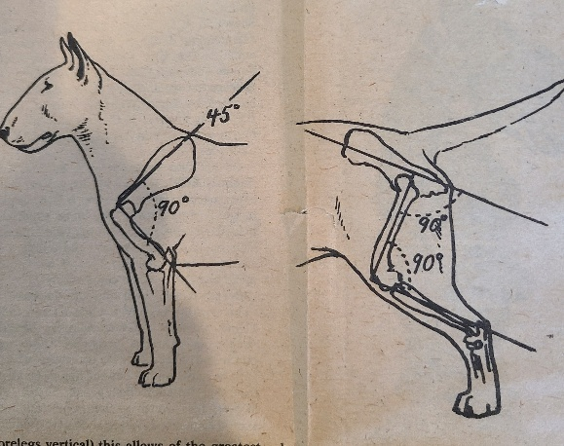
At the lower end of the blade the shoulder forms an angle with the humerus or upper arm, a bone not mentioned in the Standard but an important one which, with the shoulder, controls to a great extent the length of the dog's stride and the position of the elbows on the rib cage. Ideally the shoulder blade and upper arm should form an angle where they meet, of about 90 degrees (when the dog is standing with forelegs vertical) this allows of the greatest possible forward reach by the forelegs and the length of the upper arm controls the position of the elbow on the chest wall. If the upper arm is short, and/or steep, the angle between it and the shoulder blade will be much greater – more open than the desired 90 degrees with the result that the elbow will be brought forward on the chest and the possible length of stride of the foreleg will be lessened. If shoulders are also steep, the angle will be greater still and the stride even shorter. It is in this situation when both shoulder and upper arm are steeper than the ideal that fronts begin to go wrong. The elbow is brought too far forward, the weight of the dog's body is not adequately supported and the bones of the forelegs are put under undue strain and bent out of the straight or the elbows are pushed out in an effort to relieve the strain, and the breeder is faced with the all too familiar fault in this breed of a Bulldog front.
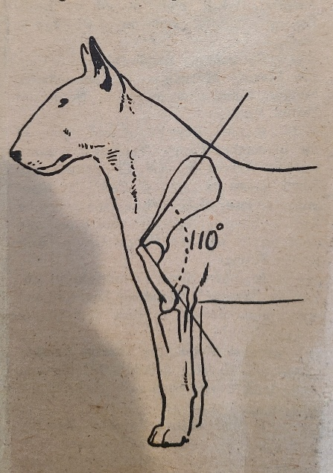
Sloping shoulders, sufficient length of upper arm, meeting the shoulder blade at the correct angle or as near to 90 degrees as can be got and elbows placed somewhat back on the chest wall are then very important points for the breeder to aim for. Sloping shoulders have the added advantage that they form the best possible base for a well arched neck and allow of a long ribcage but a short back, that however is another story.
In the hind-quarters it is the same again, bones of sufficient length to form the desired angles are the key to correct hindquarters formation and movement.
Attached to the dog's croup and below it is the pelvic girdle, a large bony structure which is positioned at an angle of 30 to 35 degrees to the horizontal and sloping away to the rear. Almost at the bottom of the pelvis are two hollows into which fit the heads of the femurs, the long bones of the dog's hind legs. Ideally to give the desired well-bent stifle the femur should be set at an angle of about 90 degrees to the pelvis, (when the dog is standing with fore and hind legs upright). This of course cannot be seen or felt in a well-muscled dog but the well bent stile can be seen and must be present if the dog is to move properly, it appears as a curving line down the front of the hind leg from the top of the legs to the hock. At its lower end the femur meets a double bone, the tibia-fibula to form the stifle joint. Here again the ideal is the right angle (90 degrees) though, possible due to the Bulldog influence, not very many Bull Terriers are as well-angulated at this point as they might be. However, it should be the breeders aim to have broad, well-muscled thighs - the thigh is the muscular covering of the femur bone - and especially well muscled second thighs - these are the muscle clad tibia fibula bones - as here is the seat of much of the dogs’ power of propulsion, the thighs and second thighs should be well covered with strong pliable muscling, seen from behind or from the side with a pronounced curve to the stifle.
At its lower end, the second thigh meets the back pastern to form the hock joint, the ideal angle for this joint is about 120 degrees but it is often nearer to 130 degrees and sad to say not infrequently much greater than that. In any case the hocks should be well marked and bony and should flex visibly as the dog moves.
The angles at stifle and hock cannot be attained without sufficient length of the bones concerned and it often happens that in breeding for short backs breeders incidentally shorten these bones too with the result that the angles at stifle and hock are much too wide to enable the legs to be extended well forward and well back. Ideally with the dog standing four square the stifle joint should come just below the pin bone (on the top of the pelvis above the croup) and the points of the hock should project just beyond a vertical line drawn through the back of the buttocks. When the stifles and hocks fall markedly short of these ideals, movement suffers, an all too common failing in Bull Terriers.
My advice to any breeder of Bull Terriers who wants to get to the top quickly would be to concentrate on breeding for correct forehands and hindquarters while taking care not to lose quality and strength in head and of course the indispensable substance. These regions are where the breed fails most persistently and any kennel that is consistently successful in this endeavor will have little to worry about in the matter of movement, will win a great deal and never lack customers for its stock or stud dogs.

