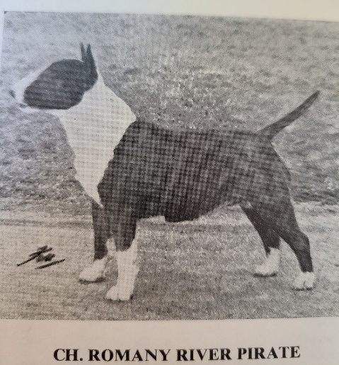
TYPE, THE INTANGIBLE
By Tom Horner, Dog World May 31, 1991.
The world of show dogs has a language all its own in which certain words have very special meanings - usually a lot narrower than when the same words are used in reference to wider matters. This applies especially to the words used to the intangible factors that play so big a part in the make-up of high-class show-dogs.
The word "type" is one of several rather vague terms we apply to dogs which are instantly recognizable to the experienced breeder, always present in the first-rate specimens of the breed, but very difficult to define precisely and which take a lot of understanding and appreciating by the newcomer to a breed. Other words of similar intangible character are "quality" and "balance". Such factors as size, height, weight and color are finite - they can be measured or a scale applied to them - but these measurements cannot be applied to the intangible which are in the observer's mind and like beauty in the human or the landscape, can only be appreciated by the beholder. Also, what adds up to good type in one breed often does not do so in other breeds, although they are very similar. A judge who promoted a Welsh Terrier with the refinement and length of head which is correct for a Fox Terrier will be considered to have put up the wrong type; just as would a judge who promoted a Hungarian Vizsla of the height and substance required by a Weimaraner. While each of the above might be of good structure and quality and move soundly they would both fail to comply with the type called for in their Standard.
A dog can appear physically perfect, move with precision and style and measure the correct height and size called for in its Standard, yet unless it has the correct type for its breed it will have no appeal for the real expert. An eye for type is indispensable to good judging of dogs; all good judges have it although they may not all agree on exactly what is the correct type for a particular breed. Ask a dozen judges to define type in any breed and you are likely to receive a dozen different answers, but all pretty close to what the Standard describes.
Perfection
It is as if these intangible properties possessed by all really good dogs are spiritual, rather than actual, although all are based on physical attributes, except for character and style.
Type as applied to dogs has a special meaning. It indicates that the set of characteristics listed in the Standard are all present and in the right proportions. No two dogs are ever exactly alike, even within a very high-class breed - always there are minor (sometimes major) differences, but over all a typical dog complies pretty closely to the Standard's requirements.
The best definition of type I have come across is : "Type is the sum of those points which make a dog like its own breed and no other." Without reasonably correct type a dog is a non-starter on the road to success in the show ring. Types within a breed can vary quite considerably. For instance, there is a distinct difference in the type of the solid and the particolored Cockers in the ring today. It may be claimed that this should not be so - all are the same breed - but there is no question that there are differences. Some breeders keep only the blacks and reds and some only roans and particolors. It may be that there are color preferences for reasons not attributable to type. Some colors are more amenable in temperament than others and some are easier to prepare for show - no names, no pack drill! Very few breeders keep both solids and coloreds. But both sectors can and do produce outstandingly good cockers. Absolute perfection of type lies at the center of a Standard's description of a breed, not at its extremes. Perfect type occurs more often, in most breeds, in bitches rather than in dogs. Exaggerations are great destroyers of type in many breeds. Big, coarse, overcoated Pekingese are currently doing a lot of winning except when the really expert judges are taking the breed. There are always breeders who try to get ahead of the other competitors by showing dogs with a bit more of this or that feature. Very soon this practice can lead to dogs which are untypical and unbalanced. An exaggerated dog will, sadly, often attract unthinking breeders to make use of its services - and so spread the drawbacks of oversize or some other bad point.
Thrilling
With breeds in which great size or weight is a desired point it is of course necessary to have males somewhere near the upper limits of the Standard's recommendations to maintain the desired type, but even in such breeds excessive height or weight can produce a variety of problems which would not arise if the Standard were more closely adhered to. In these breeds some breeders are tempted to aim for bigger and bigger specimens, with disastrous results.
The reverse often arises in the toy breeds; balance and thereby correct type is often lost when attempts are made to breed very small specimens. Here again perfection in type or its nearest approach is found in the medium sizes. Very tiny specimens may be pleasing and remarkable, but they in turn are likely to produce females too small to breed naturally, a real crime to foist upon any breed.
A dog of outstanding type is a thrilling sight and a great achievement for its breeder and for any true fancier of a breed. To be true type it does not have to be exaggerated, just to comply with the terms of its Standard and possess balance and quality plus that little extra something which makes it a "real one" and lifts it out of the rut of mediocrity and ordinariness.

